Contents

1. Pre-requisites for all servers 2

1.1. JDK 2

1.2. Talend Install files 10

1.3. Apply IPV4 settings from Jared - ELC Network Team 11

1.4. Create TAC, AMC Databases in MySQL server 14

2. TAC Setup 14

2.1. TAC Install 15

3. Job Server Setup 19

3.1. Job Server Patch Install and Fix 34

4. TAC UI and Properties Configuration 38

4.1. TAC DB Config 39

4.2. TAC memory setting 43

4.3. Miscellaneous Configuration 45

4.4. TAC cache cleanup 46

4.5. Create Logs Directories 46

5. URL and Talend Service Names 50

5.1. URL 50

5.2. Service Names 50

6. Apply SSL in TAC 51

7. TAC Patch Install 53

8. Prepare project Talend_ELCConsumerMDM in Studio 57

8.1. Create DB schema/tables/views and stored procedures in DEV mysql 57

8.2. Update DEV Context Group for mysql DB and kafka 65

8.3. Verify DB values updated and check for compilation errors in each job 68

8.4. Publish to Nexus or Build each job from studio, upload job zip to TAC task, configure contexts, test execute and view logs 70

8.5. Create Execution Plan and execute once 77

8.6. Execute same batch of data using 711 Execution Plan and 731 execution Plan and verify in Kafka Topic – HKG Plan selected 77

# Pre-requisites for all servers

Execute steps below to setup java on all servers for PROD

## JDK

**(10.253.208.102)**

|  |
| --- |
| sudo su - |
| cd /usr/lib |
| mkdir jvm |
| chmod -R 777 jvm |
|  |
| scp -r ckotipal@estee.com@10.253.208.102:/home/ap.elcompanies.net/ckotipal/TalendInstallFiles/* /home/ap.elcompanies.net/ckotipal/TalendInstallFiles/  cp /home/ap.elcompanies.net/ckotipal/TalendInstallFiles/jdk-8u261-linux-x64.tar.gz /usr/lib/jvm |
|  |
| cd /usr/lib/jvm  chmod -R 777 . |
| tar -xvf jdk-8u261-linux-x64.tar.gz |
| |  | | --- | | cd /etc/profile.d | | sudo vi jdk.sh | | export JAVA_HOME=/usr/lib/jvm/jdk1.8.0_261 | | export JRE_HOME=//usr/lib/jvm/jdk1.8.0_261/jre | | export PATH=$JAVA_HOME/bin:$JRE_HOME/bin:$PATH  Hit esc then :wq! |      |  | | --- | | Restart session and Login  sudo su -  java -version |   **(10.253.208.103)**   |  | | --- | | sudo su - | | cd /usr/lib | | mkdir jvm | | chmod -R 777 jvm | | scp -r ckotipal@estee.com@10.253.208.102:/home/ap.elcompanies.net/ckotipal/TalendInstallFiles/* /home/ap.elcompanies.net/ckotipal/TalendInstallFiles/  cp /home/ap.elcompanies.net/ckotipal/TalendInstallFiles/jdk-8u261-linux-x64.tar.gz /usr/lib/jvm | | cd /usr/lib/jvm  chmod -R 777 . | | tar -xvf jdk-8u261-linux-x64.tar.gz | |
| cd /etc/profile.d |
| sudo vi jdk.sh |
|  |
| export JAVA_HOME=/usr/lib/jvm/jdk1.8.0_261 |
| export JRE_HOME=//usr/lib/jvm/jdk1.8.0_261/jre |
| export PATH=$JAVA_HOME/bin:$JRE_HOME/bin:$PATH |
| Hit esc then :wq!  **(10.253.208.103)**    Restart session and Login  sudo su -  java –version |
|  |
|  |
| **(10.253.208.101)** |
| sudo su - |
| cd /usr/lib |
| mkdir jvm |
| chmod -R 777 jvm |
|  |
| scp -r ckotipal@estee.com@10.253.208.102:/home/ap.elcompanies.net/ckotipal/TalendInstallFiles/* /home/ap.elcompanies.net/ckotipal/TalendInstallFiles/  cp /home/ap.elcompanies.net/ckotipal/TalendInstallFiles/jdk-8u261-linux-x64.tar.gz /usr/lib/jvm |
|  |
| cd /usr/lib/jvm  chmod -R 777 . |
| tar -xvf jdk-8u261-linux-x64.tar.gz    cd /etc/profile.d  sudo vi jdk.sh  export JAVA_HOME=/usr/lib/jvm/jdk1.8.0_261  export JRE_HOME=//usr/lib/jvm/jdk1.8.0_261/jre  export PATH=$JAVA_HOME/bin:$JRE_HOME/bin:$PATH  Hit esc then :wq!    Restart session and Login  sudo su -  java –version    **(10.253.208.100)**   |  | | --- | | sudo su - | | cd /usr/lib | | mkdir jvm | | chmod -R 777 jvm | | scp -r ckotipal@estee.com@10.253.208.102:/home/ap.elcompanies.net/ckotipal/TalendInstallFiles/* /home/ap.elcompanies.net/ckotipal/TalendInstallFiles/  cp /home/ap.elcompanies.net/ckotipal/TalendInstallFiles/jdk-8u261-linux-x64.tar.gz /usr/lib/jvm  cd /usr/lib/jvm  chmod -R 777 . | | tar -xvf jdk-8u261-linux-x64.tar.gz |     cd /etc/profile.d  sudo vi jdk.sh  export JAVA_HOME=/usr/lib/jvm/jdk1.8.0_261  export JRE_HOME=//usr/lib/jvm/jdk1.8.0_261/jre  export PATH=$JAVA_HOME/bin:$JRE_HOME/bin:$PATH  Hit esc then :wq!  Restart session and Login  sudo su -  java –version    **(10.253.208.104)**   |  | | --- | | sudo su - | | cd /usr/lib | | mkdir jvm | | chmod -R 777 jvm | | cp /home/ap.elcompanies.net/kshah/TalendInstallFiles/jdk-8u261-linux-x64.tar.gz /usr/lib/jvm  cd /usr/lib/jvm  chmod -R 777 . | | tar -xvf jdk-8u261-linux-x64.tar.gz  cd /etc/profile.d  sudo vi jdk.sh    export JAVA_HOME=/usr/lib/jvm/jdk1.8.0_261  export JRE_HOME=//usr/lib/jvm/jdk1.8.0_261/jre  export PATH=$JAVA_HOME/bin:$JRE_HOME/bin:$PATH    Hit esc then :wq!  Restart session and Login  sudo su -  java –version | |

## Talend Install files

Request Estee team to deploy Talend Install files (.zip, dist and license) under /home/<user> path for each server

Execute commands below

|  |
| --- |
| cd /home/schundur |
| sudo su - |
|  |
| cd /home/schundur |
| chmod -R 777 . |
| unzip Talend-Installer-Starter-20181026_1147-V7.1.1-installer.zip |
| chmod -R 777 . |
|  |
| cd /opt |
| mkdir Talend-7.1.1 |
| chmod -R 777 . Apply IPV4 settings from Jared - ELC Network Team |

sudo su -

cd /etc/sysctl.d

vi 90-keepalive.conf

<add below lines>

net.ipv4.tcp_keepalive_intvl = 60

net.ipv4.tcp_keepalive_probes = 30

net.ipv4.tcp_keepalive_time = 180

*SAVE*

*run*

sysctl -f 90-keepalive.conf

This above is the change that fixed hanging jobs

It changes from these values

net.ipv4.tcp_keepalive_intvl = 75

net.ipv4.tcp_keepalive_probes = 9

net.ipv4.tcp_keepalive_time = 7200

to these:

net.ipv4.tcp_keepalive_intvl = 60

net.ipv4.tcp_keepalive_probes = 30

net.ipv4.tcp_keepalive_time = 180

To REVERT, simply change the values in the file and run the sysctl command again.

**(10.253.208.102)**

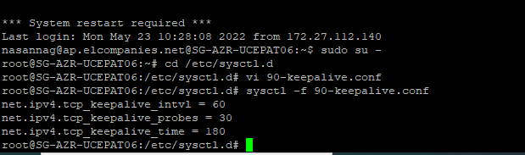

**(10.23.208.104)**

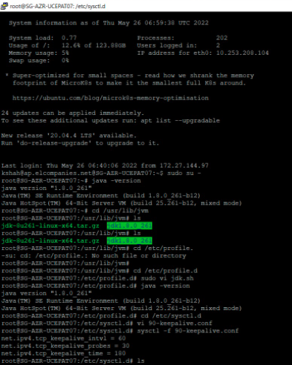

**(10.253.208.100)**

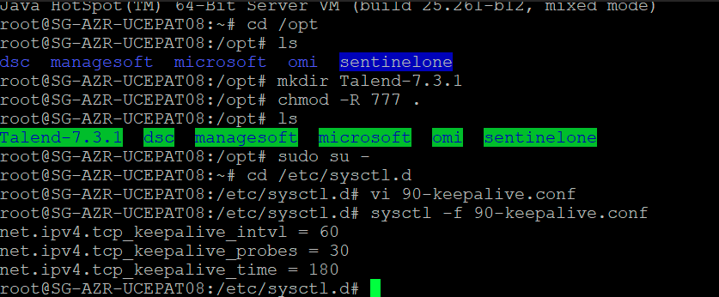

**(10.253.208.103)**

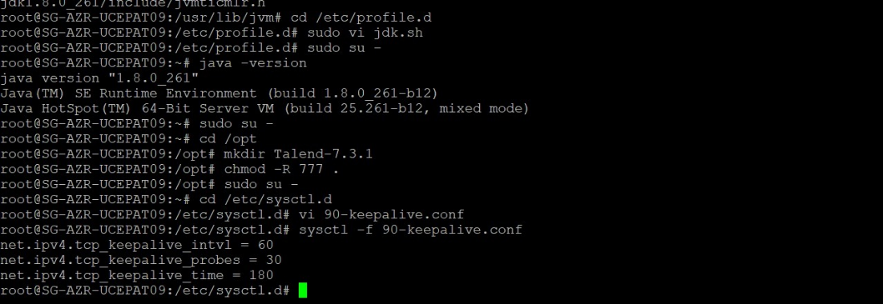

**10.253.208.101**

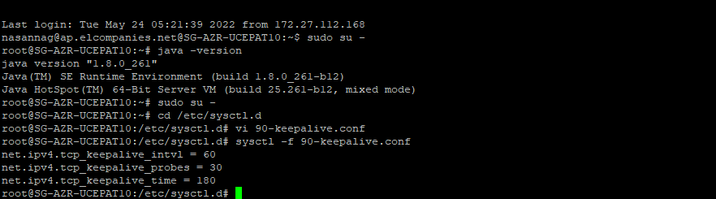

## Create TAC, AMC Databases in MySQL server

create database talend_administrator731;

create database talend_amc731;

create database mdmlanding;

create database mdmintermediate;

create database elcconsumermdm;

create database talend_metadata;

# TAC Setup

## TAC Install

**We installed tac in 10.253.208.100 server**

**UAT TAC SERVER (10.253.208.100)**

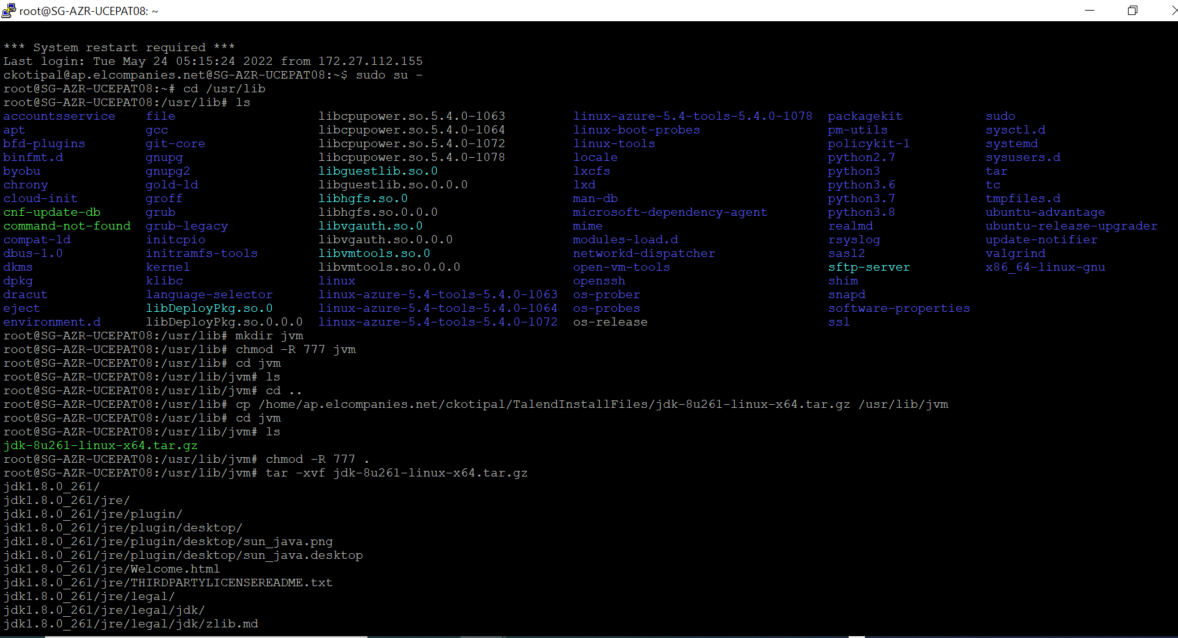

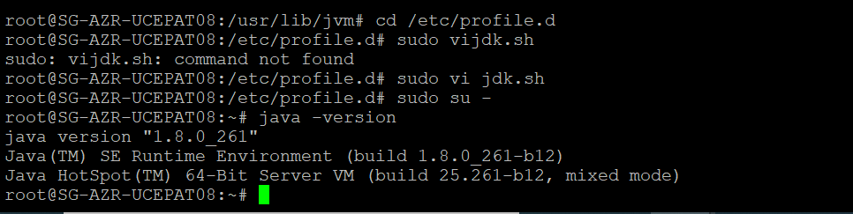

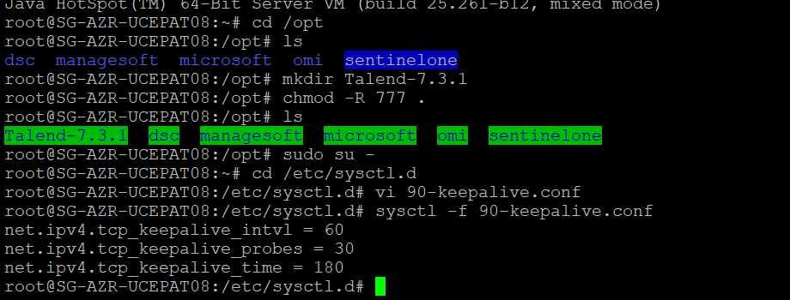

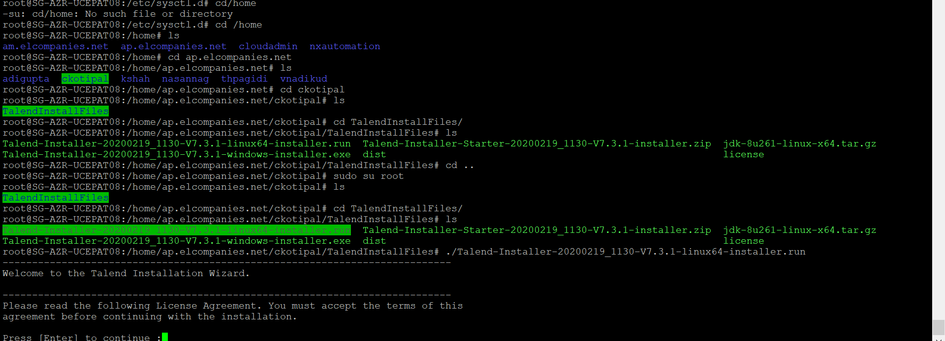

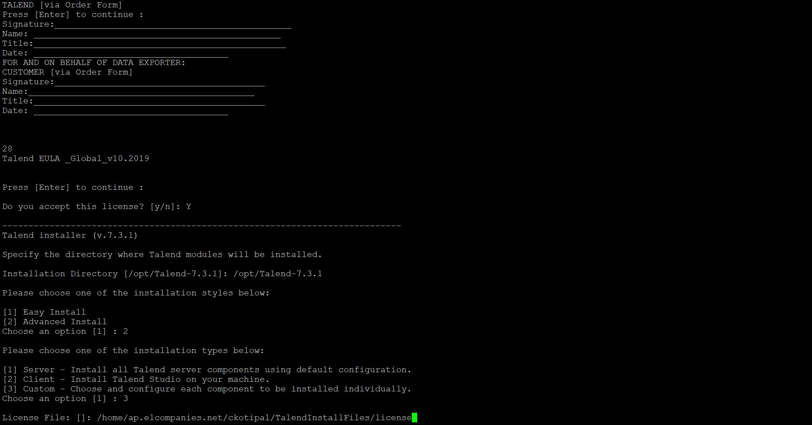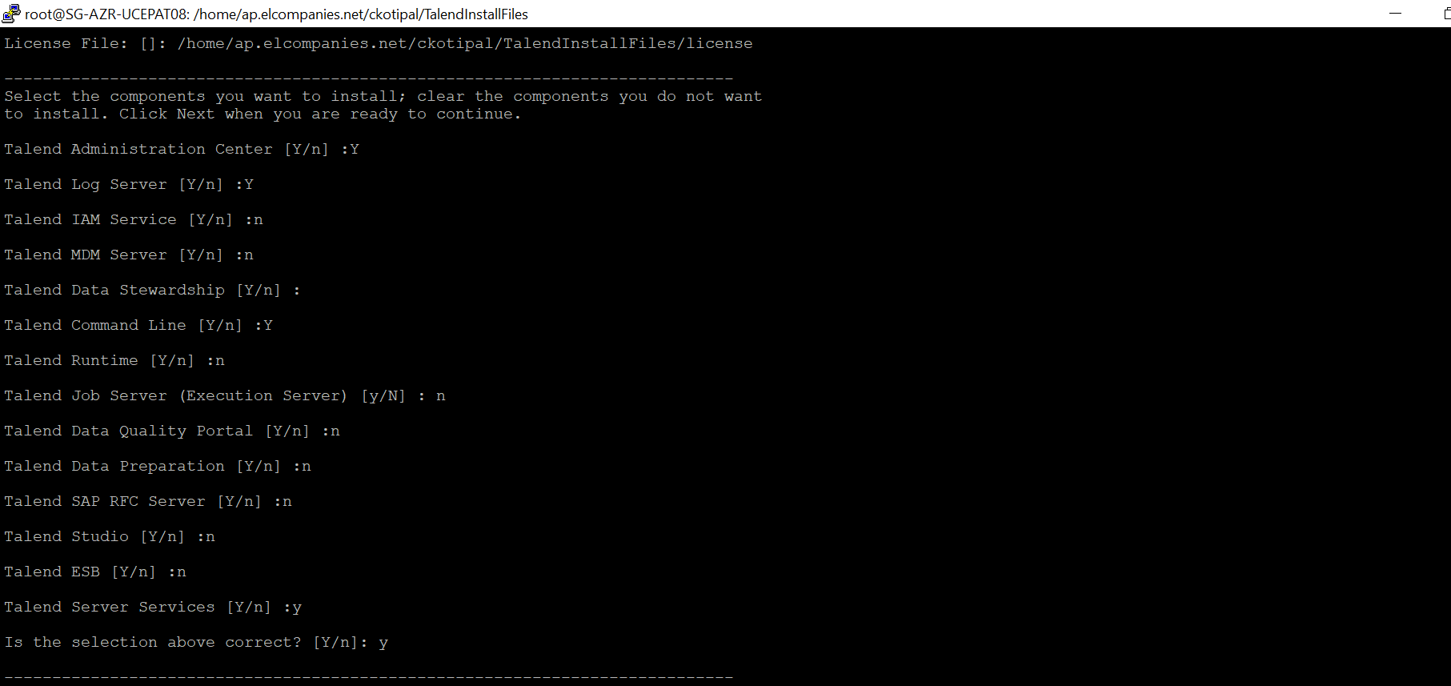

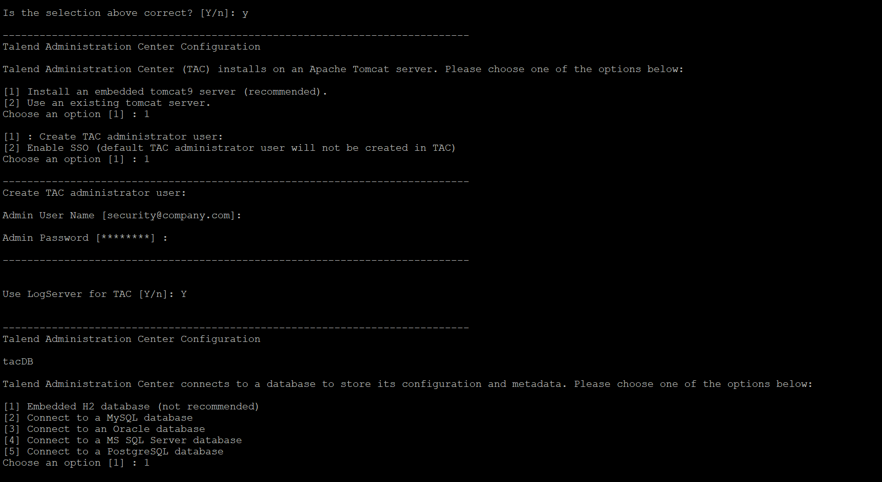

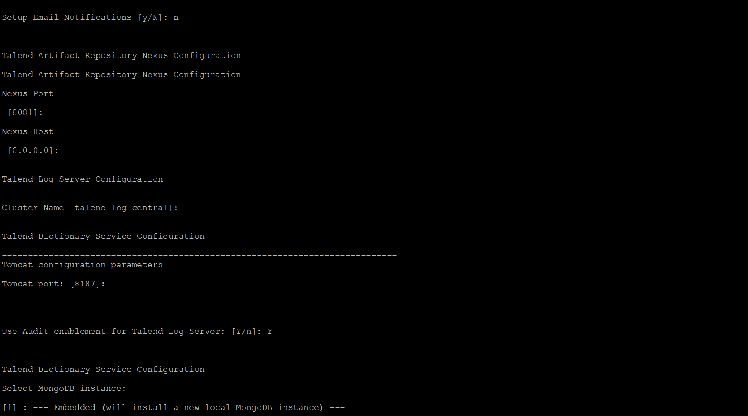

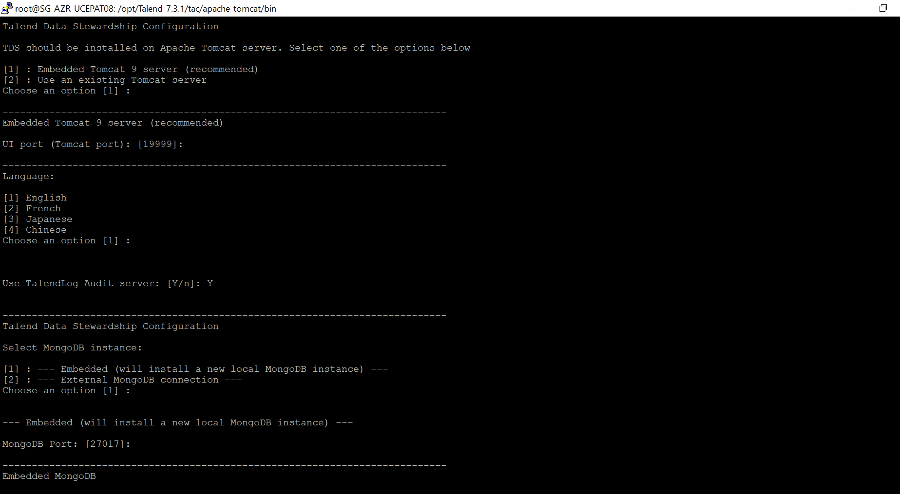

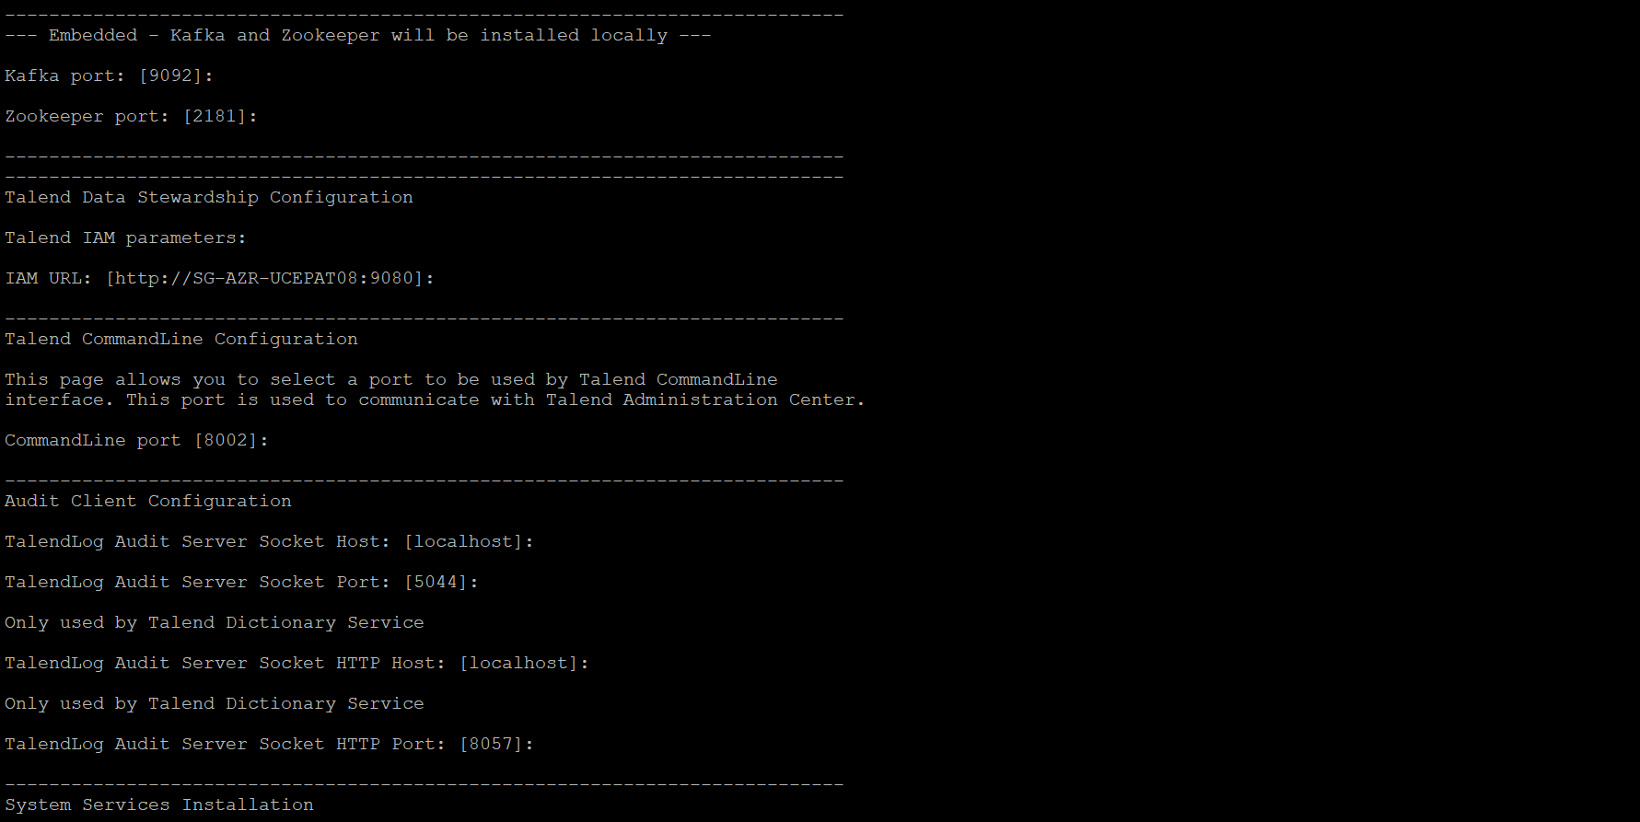

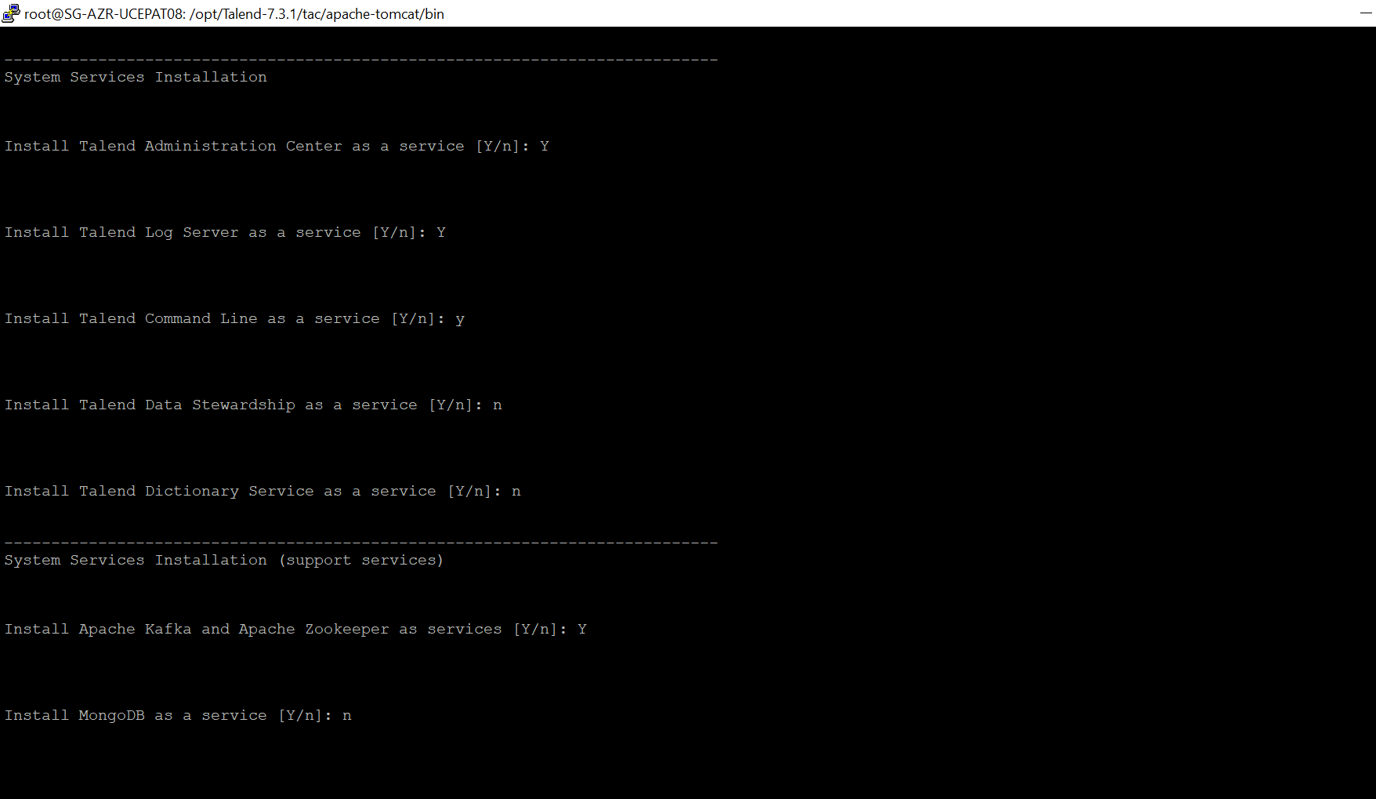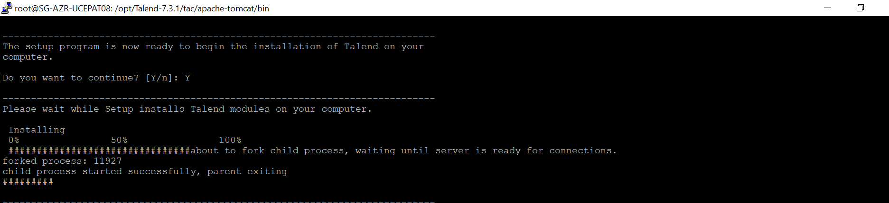

# Job Server Setup

**SG-AZR-UUCEPAT06** (**10.253.208.102)**

|  |
| --- |
| cd /home/ap.elcompanies.net/ckotipal/TalendInstallFiles  chmod -R 777 .  cd /opt  mkdir Talend-7.3.1  chmod -R 777 Talend-7.3.1/  ls  cd /home/ap.elcompanies.net/ckotipal/TalendInstallFiles  apt install unzip  unzip Talend-Installer-Starter-20200219_1130-V7.3.1-installer.zip  chmod -R 777 . |
|  |

./Talend-Installer-20200219_1130-V7.3.1-linux64-installer.run

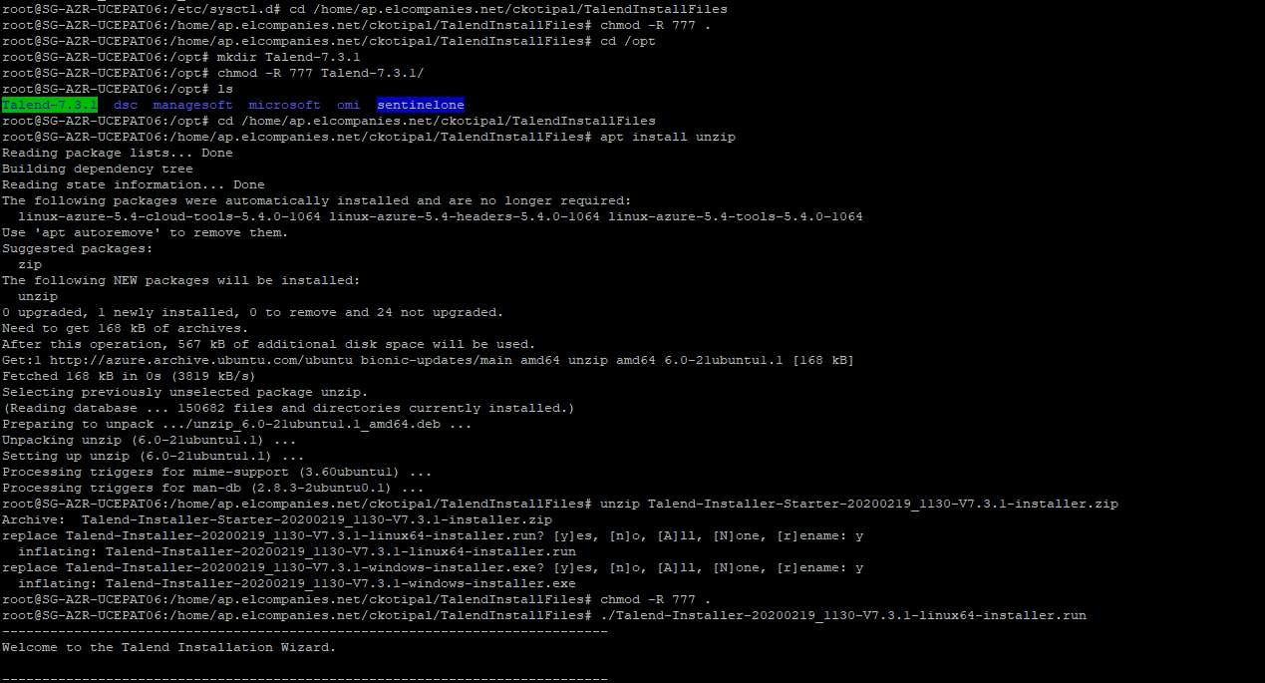

Path for Install

/opt/Talend-7.3.1

Path for License

/home/ap.elcompanies.net/ckotipal/TalendInstallFiles/license

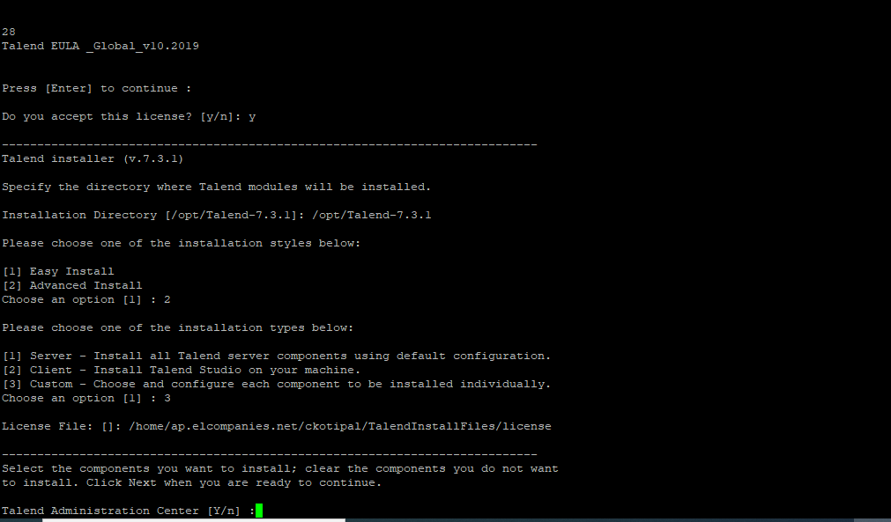

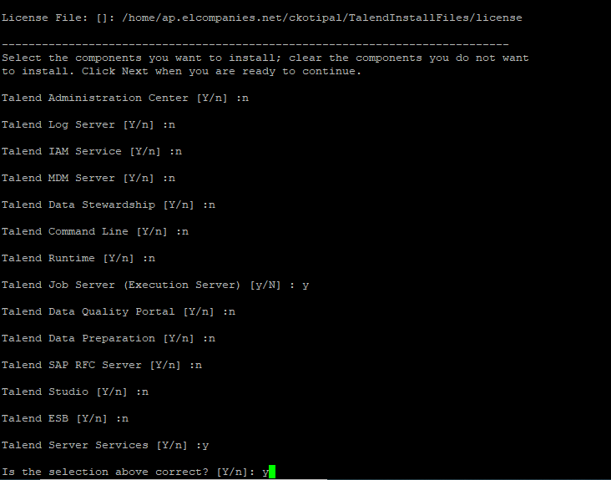

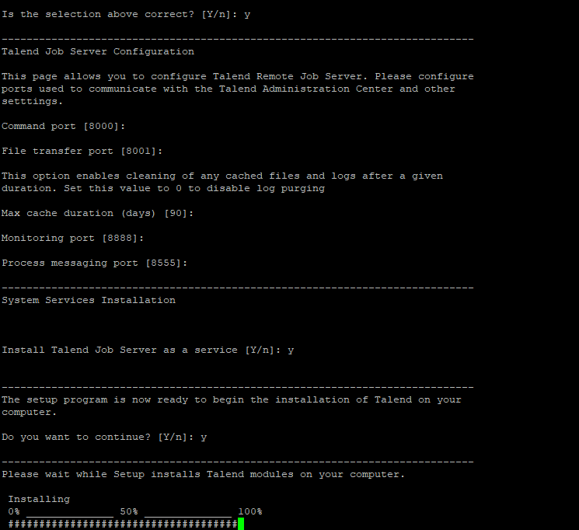

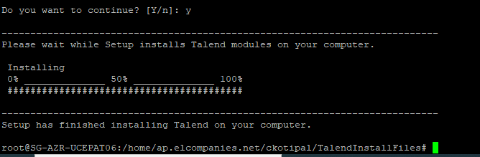

Check Job Server service

service talend-rjs-7.3.1 status

10.253.208.102

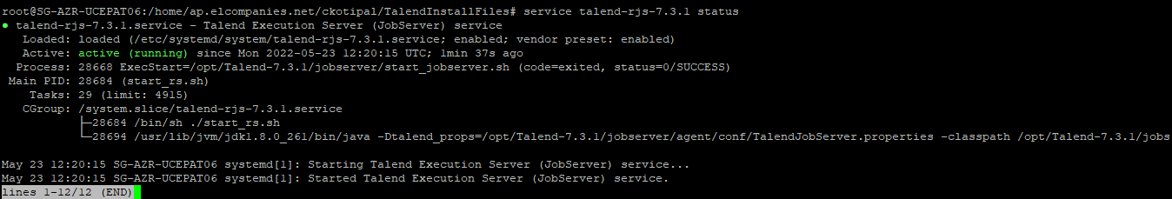

Check Job Server Log

cd /opt/Talend-7.3.1/jobserver/agent/

tail -300 jobserver.log

10.253.208.102

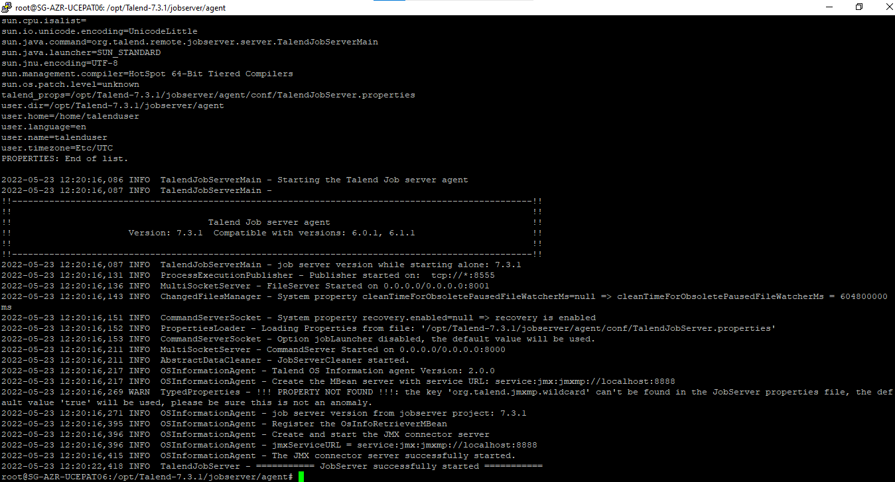

Service status

service talend-rjs-7.3.1 stop

service talend-rjs-7.3.1 start

service talend-rjs-7.3.1 status

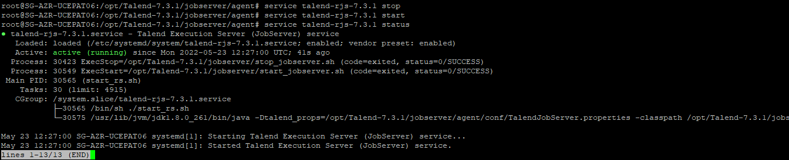

**SG-AZR-UUCEPAT09 (10.253.208.103)**

|  |
| --- |
| cd /home/ap.elcompanies.net/ckotipal/TalendInstallFiles  chmod -R 777 .  cd /opt  mkdir Talend-7.3.1  chmod -R 777 Talend-7.3.1/  ls  cd /home/ap.elcompanies.net/ ckotipal/TalendInstallFiles  apt install unzip  unzip Talend-Installer-Starter-20200219_1130-V7.3.1-installer.zip  chmod -R 777 . |
|  |

./Talend-Installer-20200219_1130-V7.3.1-linux64-installer.run

Path for Install

/opt/Talend-7.3.1

Path for License

/home/ap.elcompanies.net/ckotipal/TalendInstallFiles/license

10.253.208.103

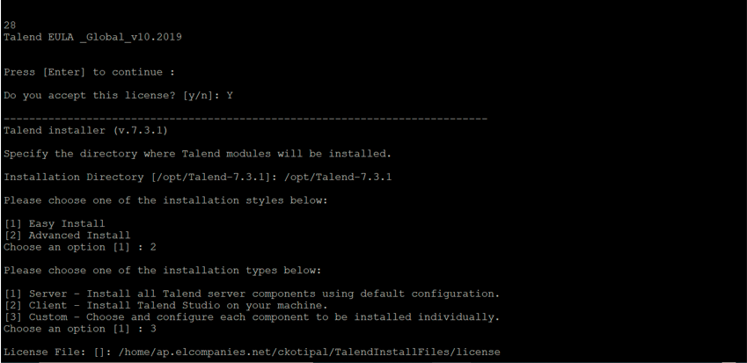

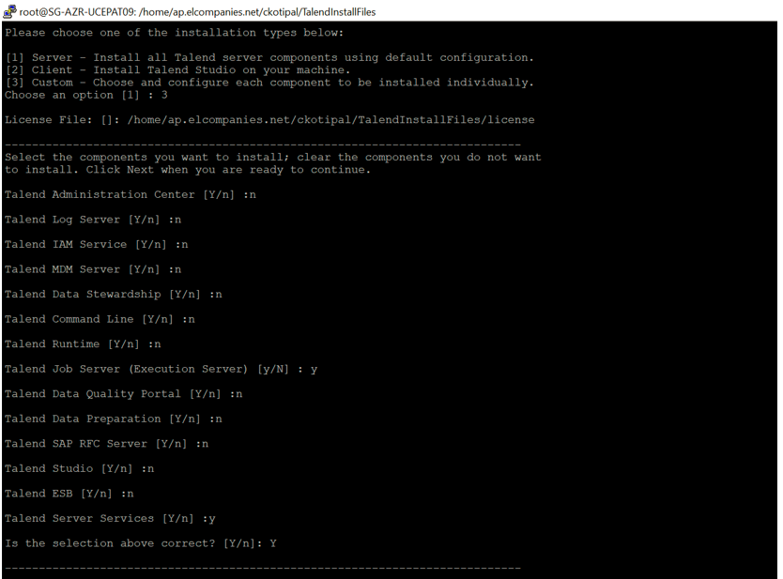

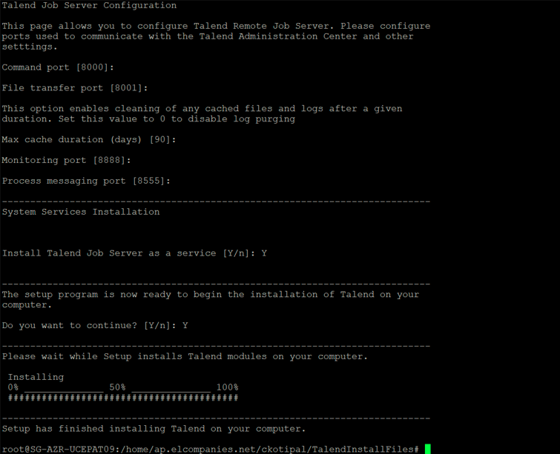

Check Job Server service

service talend-rjs-7.3.1 status

10.253.208.103

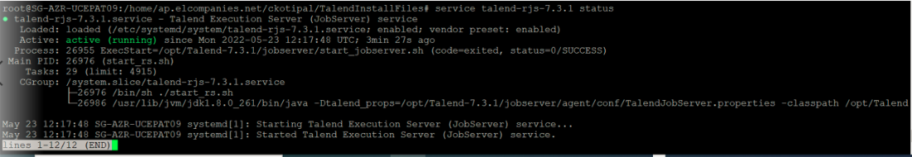

Check Job Server Log

cd /opt/Talend-7.3.1/jobserver/agent/

tail -300 jobserver.log

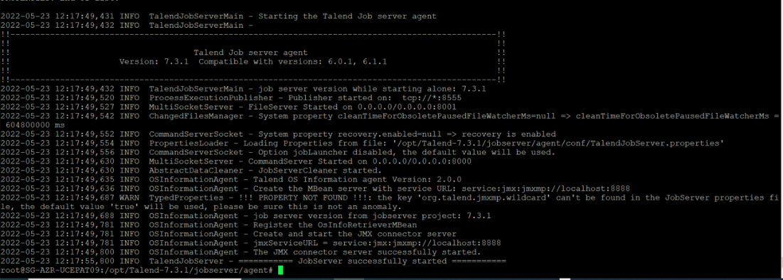

Service status

service talend-rjs-7.3.1 stop

service talend-rjs-7.3.1 start

service talend-rjs-7.3.1 status



**SG-AZR-UUCEPAT10 ( 10.253.208.101)**

|  |
| --- |
| cd /home/ap.elcompanies.net/ckotipal/TalendInstallFiles  chmod -R 777 .  cd /opt  mkdir Talend-7.3.1  chmod -R 777 Talend-7.3.1/  ls  cd /home/ap.elcompanies.net/ckotipal/TalendInstallFiles  apt install unzip  unzip Talend-Installer-Starter-20200219_1130-V7.3.1-installer.zip  chmod -R 777 . |
|  |

./Talend-Installer-20200219_1130-V7.3.1-linux64-installer.run

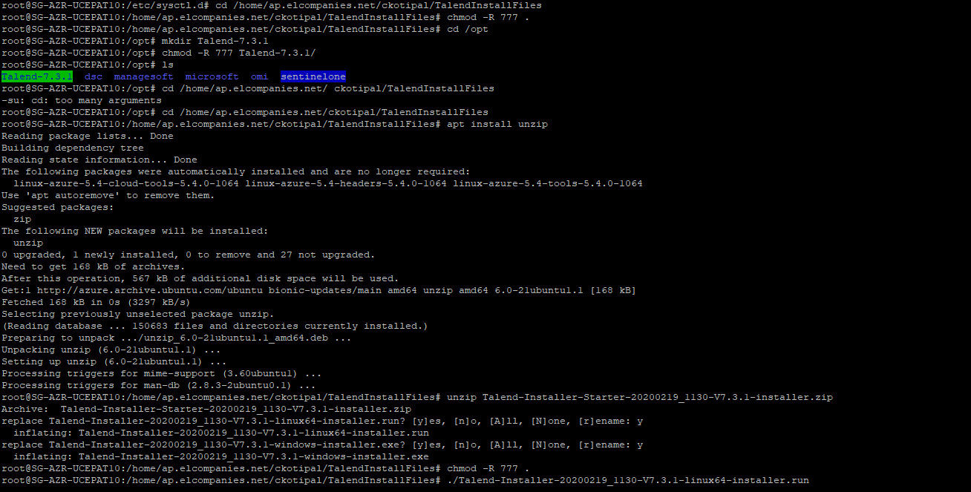

Path for Install

/opt/Talend-7.3.1

Path for License

/home/ap.elcompanies.net/ckotipal/TalendInstallFiles/license

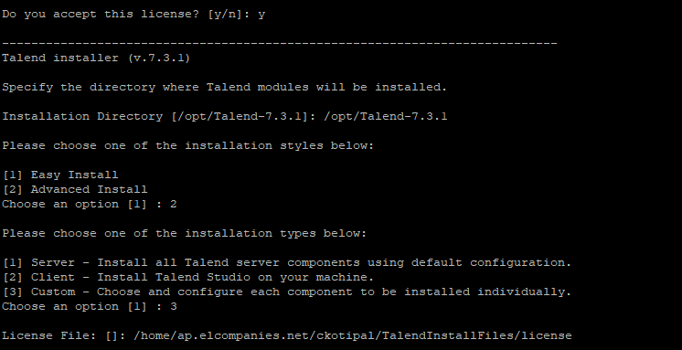

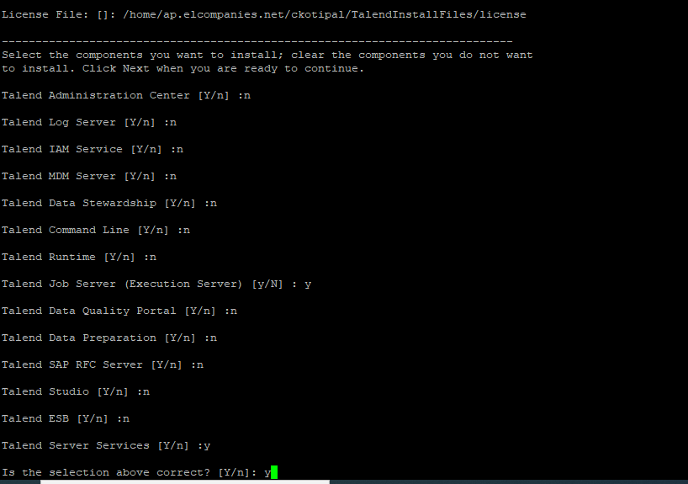

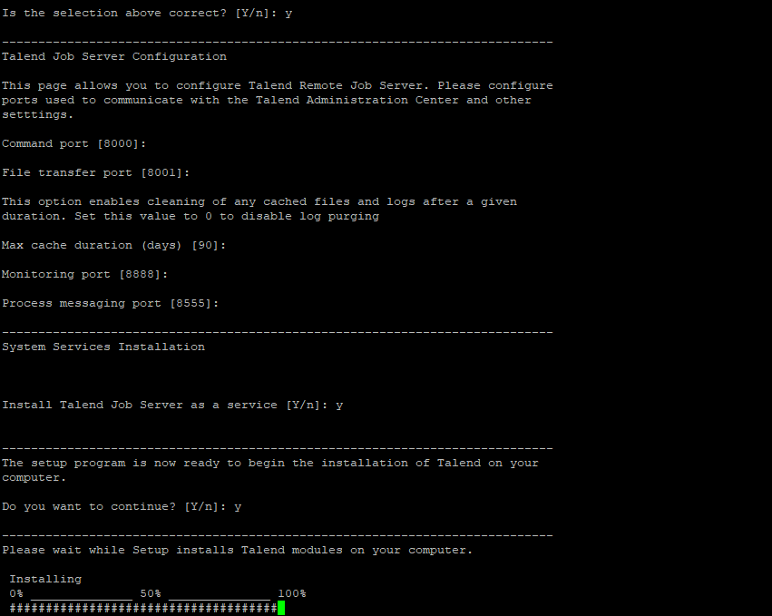

Check Job Server service

service talend-rjs-7.3.1 status

10.253.208.101

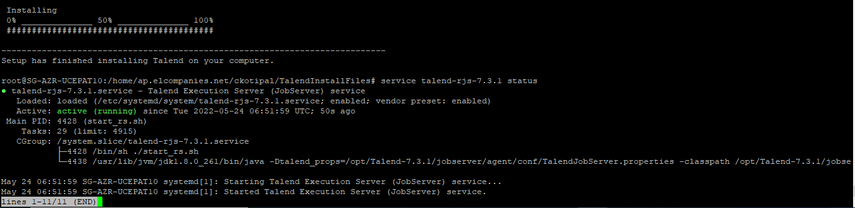

Check Job Server Log

cd /opt/Talend-7.3.1/jobserver/agent/

tail -300 jobserver.log

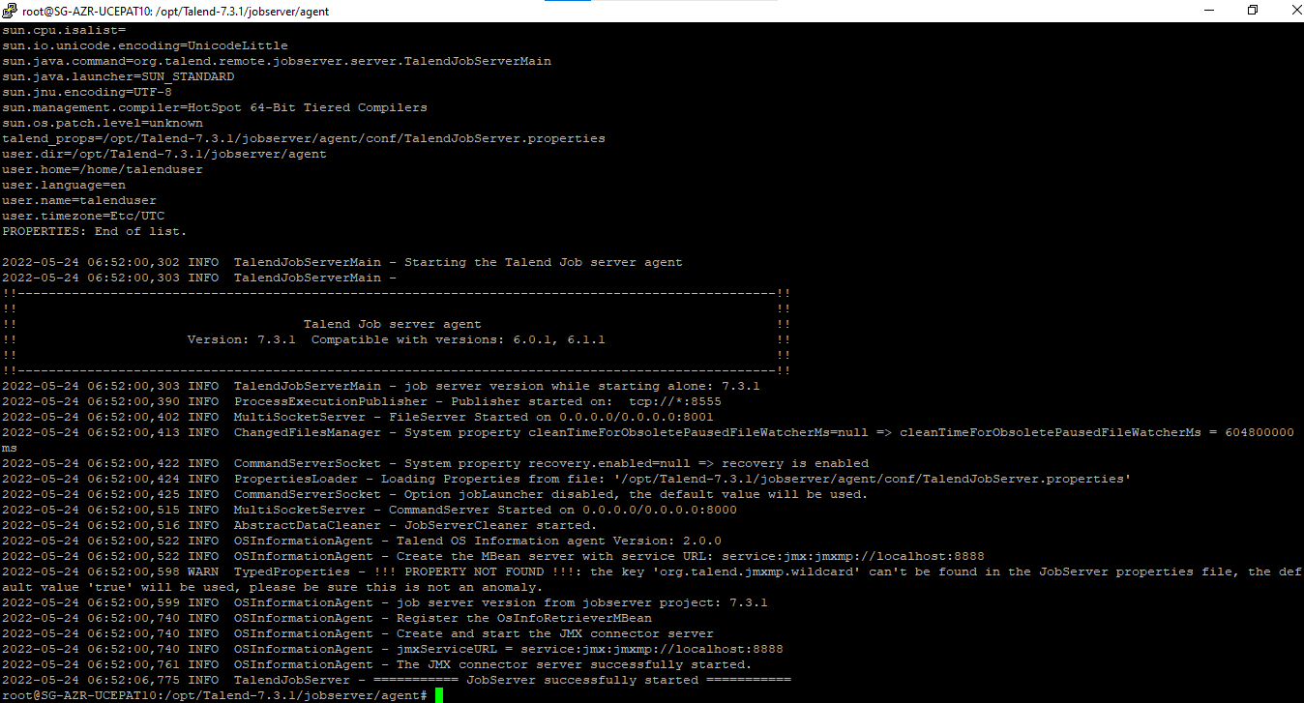

Service status

service talend-rjs-7.3.1 stop

service talend-rjs-7.3.1 start

service talend-rjs-7.3.1 status

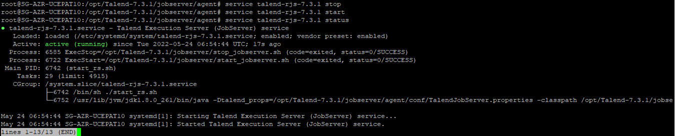

**SG-AZR-UUCEPAT07  (10.253.208.104)**

|  |
| --- |
| cd /home/ap.elcompanies.net/kshah/TalendInstallFiles  chmod -R 777 .  cd /opt  mkdir Talend-7.3.1  chmod -R 777 Talend-7.3.1/  ls  cd /home/ap.elcompanies.net/kshah/TalendInstallFiles  apt install unzip    unzip Talend-Installer-Starter-20200219_1130-V7.3.1-installer.zip  chmod -R 777 . |
|  |

./Talend-Installer-20200219_1130-V7.3.1-linux64-installer.run

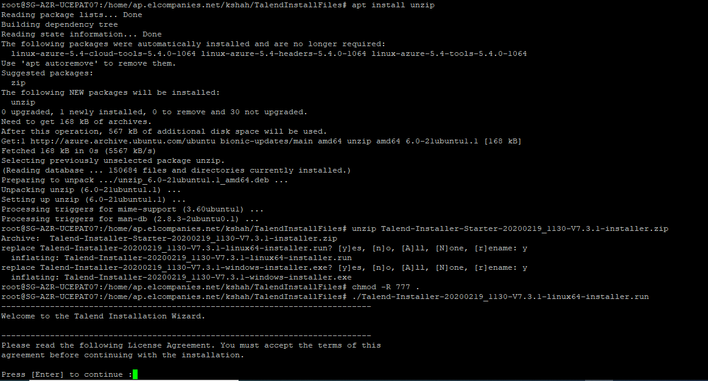

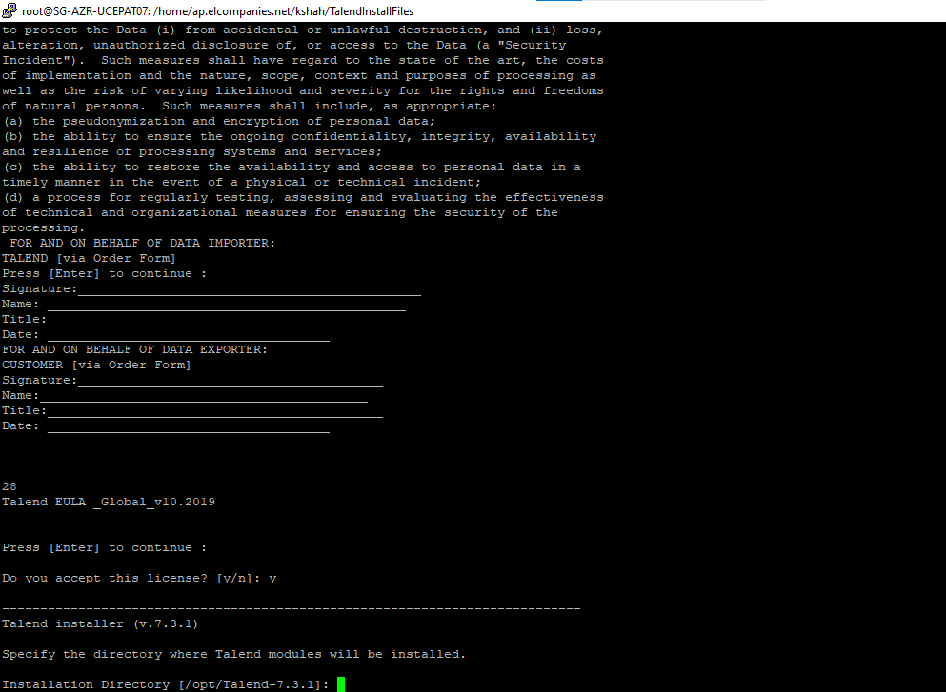

Path for Install

/opt/Talend-7.3.1

Path for License

/home/ap.elcompanies.net/kshah/TalendInstallFiles/license

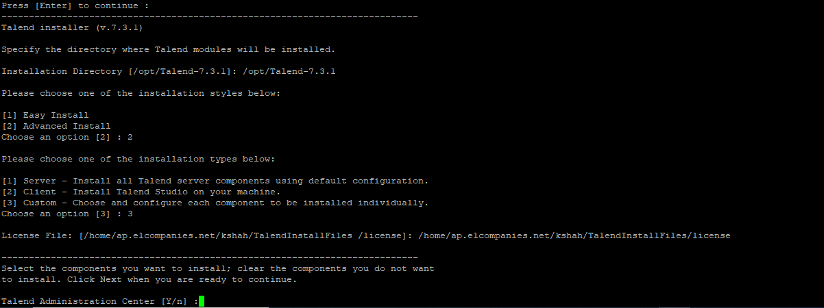

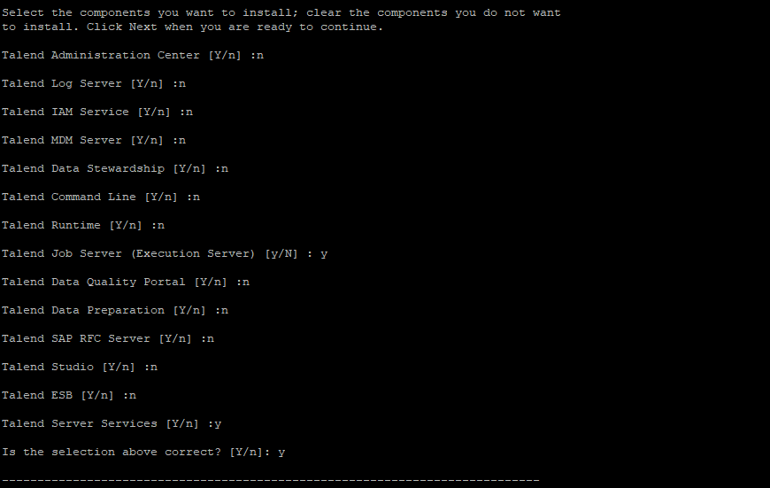

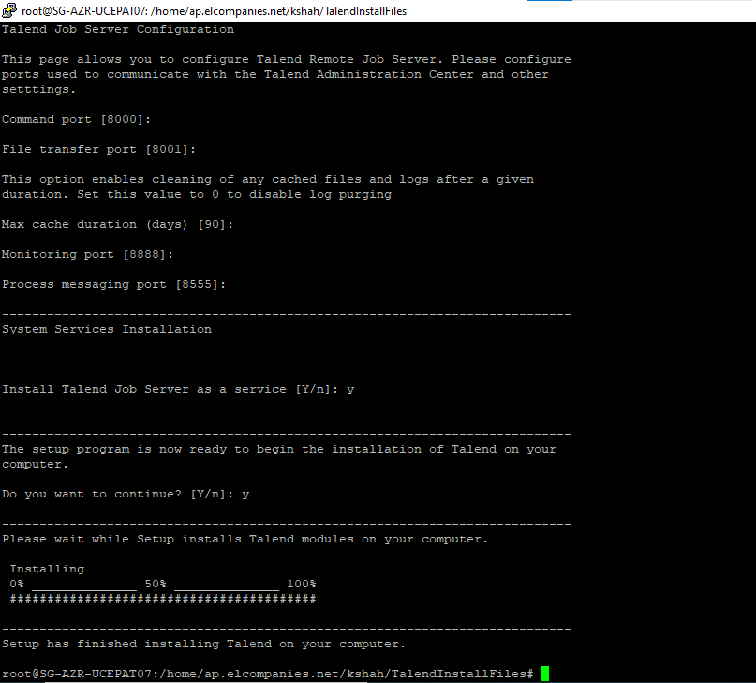

Check Job Server service

service talend-rjs-7.3.1 status

10.253.208.104

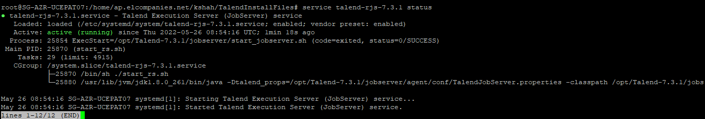

Check Job Server Log

cd /opt/Talend-7.3.1/jobserver/agent/

tail -300 jobserver.log

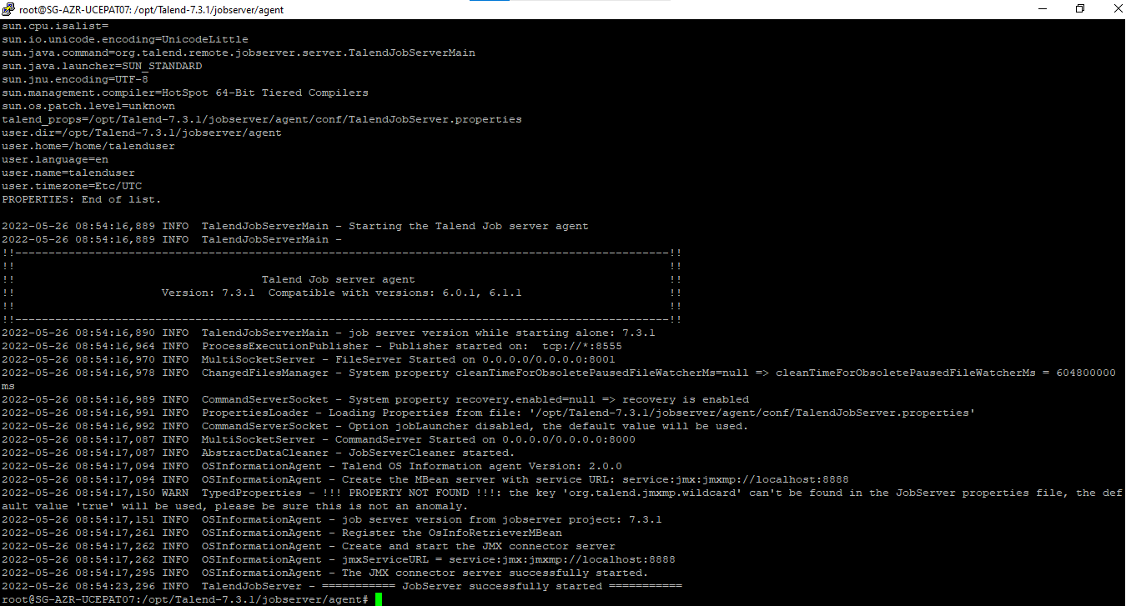

Check job server status (10.253.208.104)

service talend-rjs-7.3.1 stop

service talend-rjs-7.3.1 start

service talend-rjs-7.3.1 status

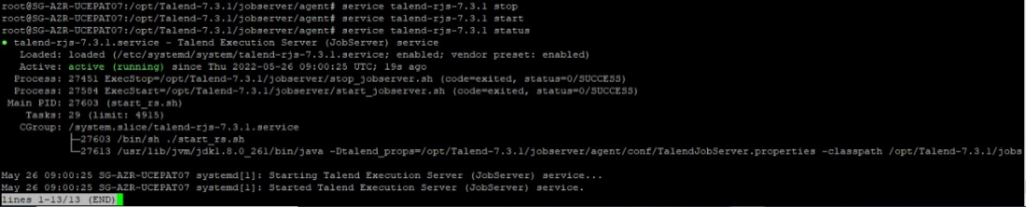

## 3.1. Job Server Patch Install and Fix

1. **10.253.208.101**
2. Install Patch as instructed in Patch Readme file
3. Then execute steps below

cd /opt/Talend-7.3.1

chown -R root:root .

chmod -R 777 .

ls -lrt

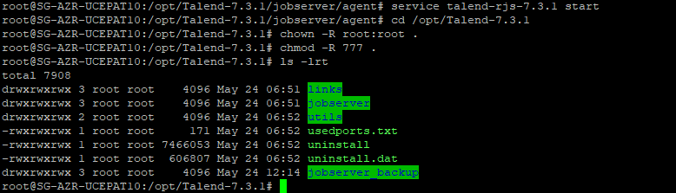

1. Edit user and group in Service and Start Service

cd /etc/systemd/system

vi talend-rjs-7.3.1.service

apply user=root and group =root

:wq!

service talend-rjs-7.3.1 status

systemctl daemon-reload

service talend-rjs-7.3.1 start

service talend-rjs-7.3.1 status

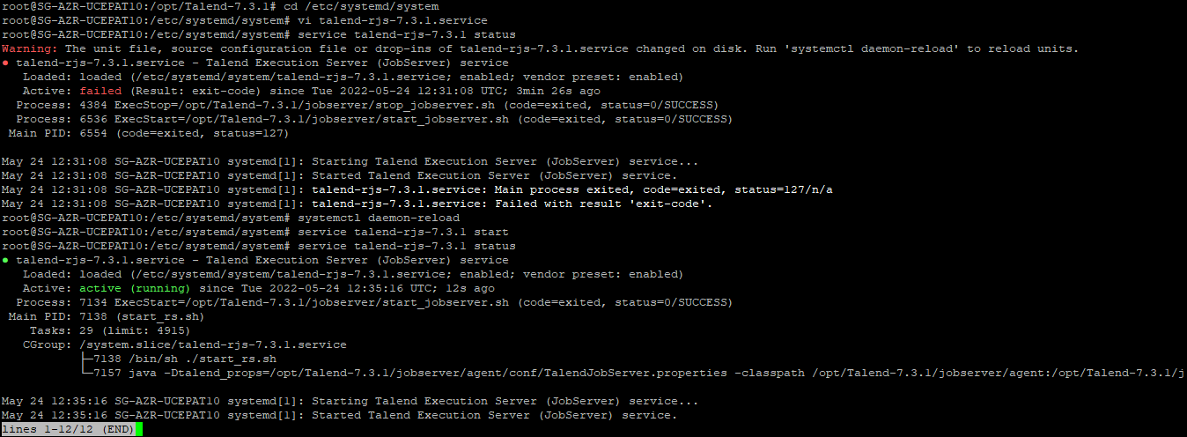

1. Verify Server is UP in TAC -> Servers Page

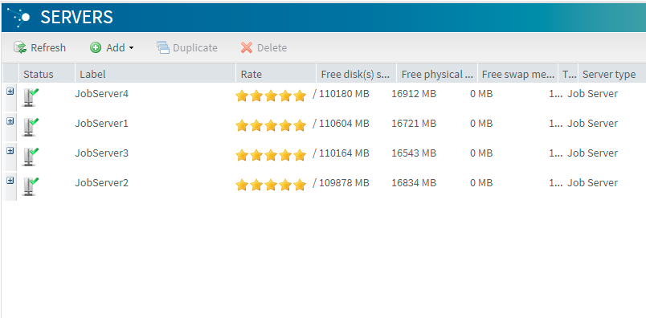

**B. 10.253.208.102**

Apply exactly the same steps as above for **10.253.208.102** server

service talend-rjs-7.3.1 status

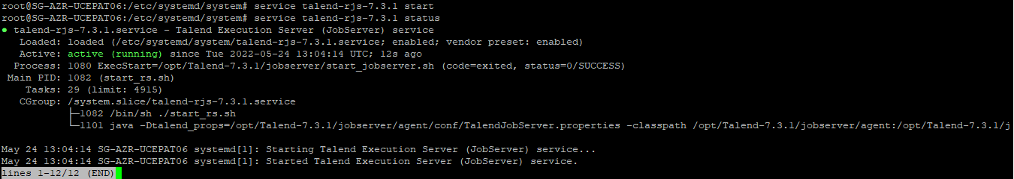

Server is UP in TAC -> Servers Page



**c. 10.253.208.103**

Apply exactly the same steps as above for **10.253.208.103** server

service talend-rjs-7.3.1 status

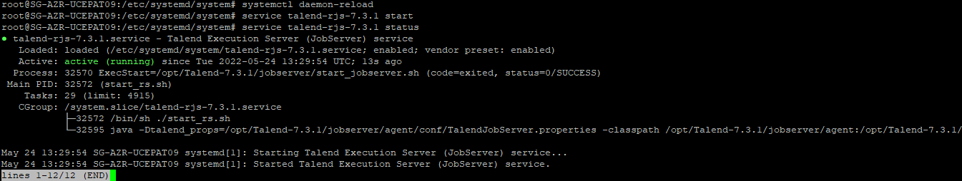

Server is UP in TAC -> Servers Page



**D. 10.253.208.104 :**

Apply exactly the same steps as above for **10.253.208.104** server

service talend-rjs-7.3.1 status

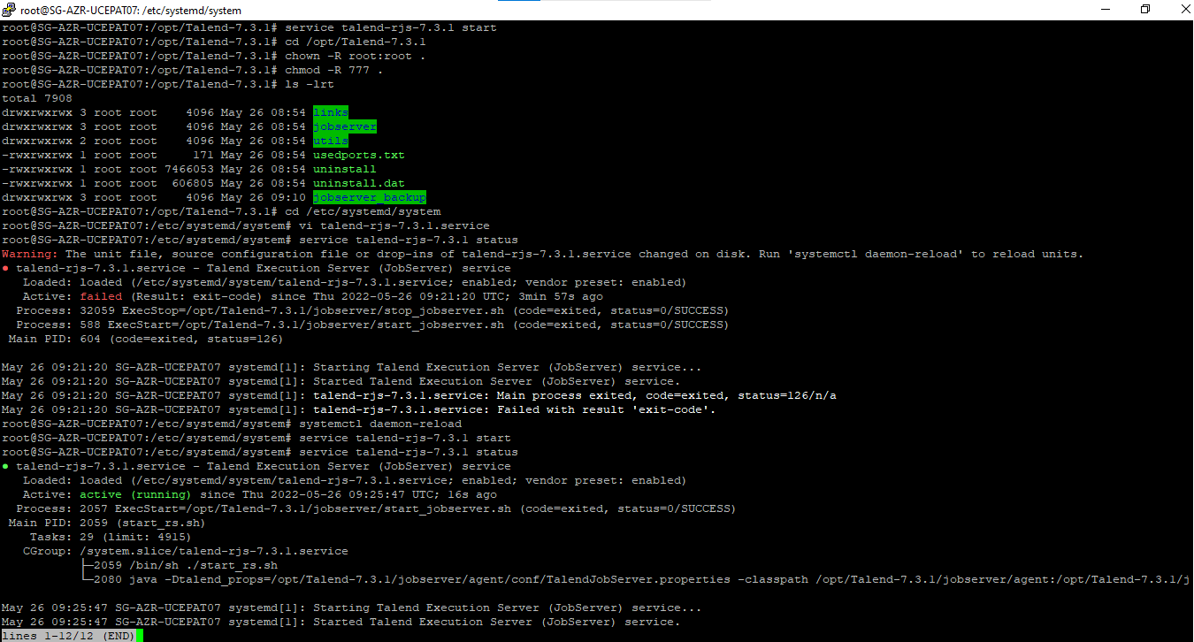

Server is UP in TAC -> Servers Page



# TAC UI and Properties Configuration

## TAC DB Config

**Servers Configuration:**

**UAT (10.253.208.100)**

Export Database talend_administrator731 from APAC UAT DB server and import into talend_administrator731 in Korea UAT DB server

Truncate taskexecutionhistory table in UAT DB talend_administrator731

Apply url in TAC ui db config page (db config page default password is admin)

org.gjt.mm.mysql.Driver

|  |
| --- |
| jdbc:mysql://mysql-ap-southeastasia-uat-cepa-06-new.mysql.database.azure.com:3306/talend_administrator731?useSSL=true&requireSSL=false&serverTimezone=UTC |
| mysql-ap-southeastasia-uat-cepa-data-06-new.mysql.database.azure.com |
| [mysqladmin@mysql-ap-southeastasia-uat-cepa-data-06-new](mailto:mysqladmin@mysql-ap-southeastasia-uat-cepa-data-06-new) |
|  |

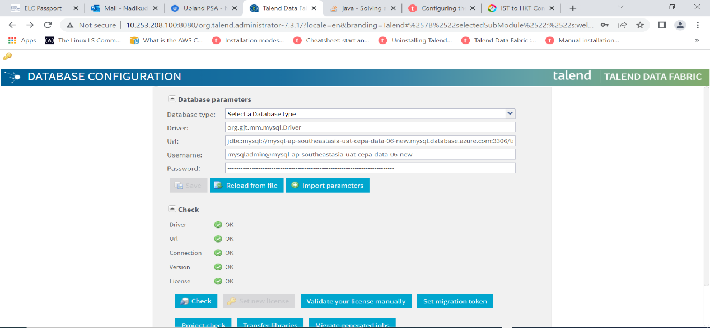

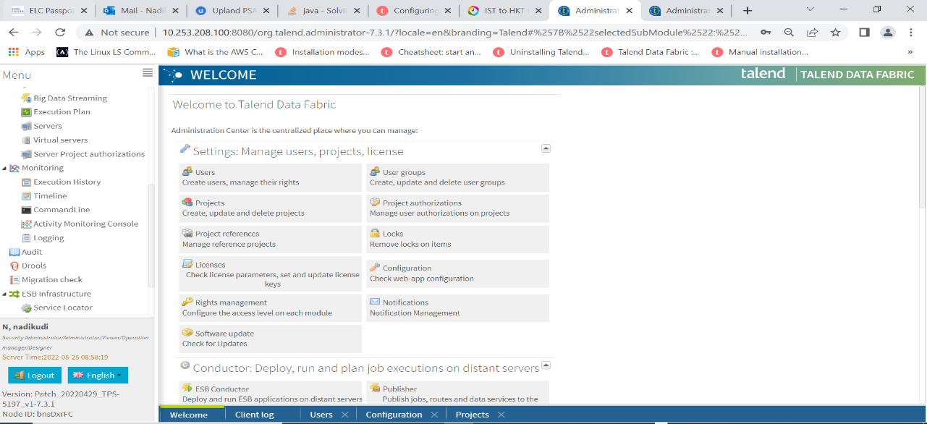

**User creation**

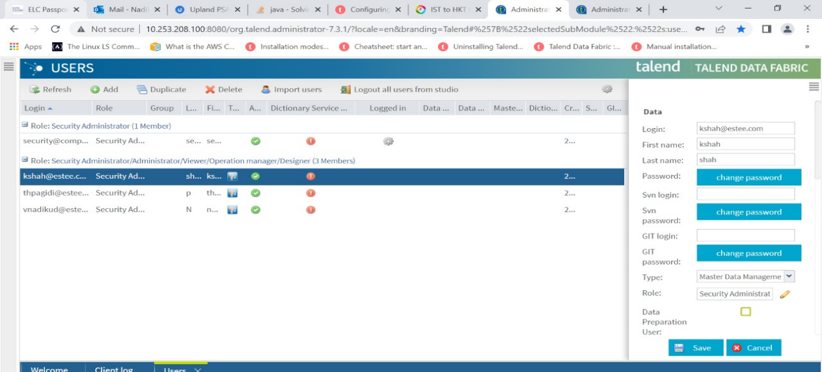

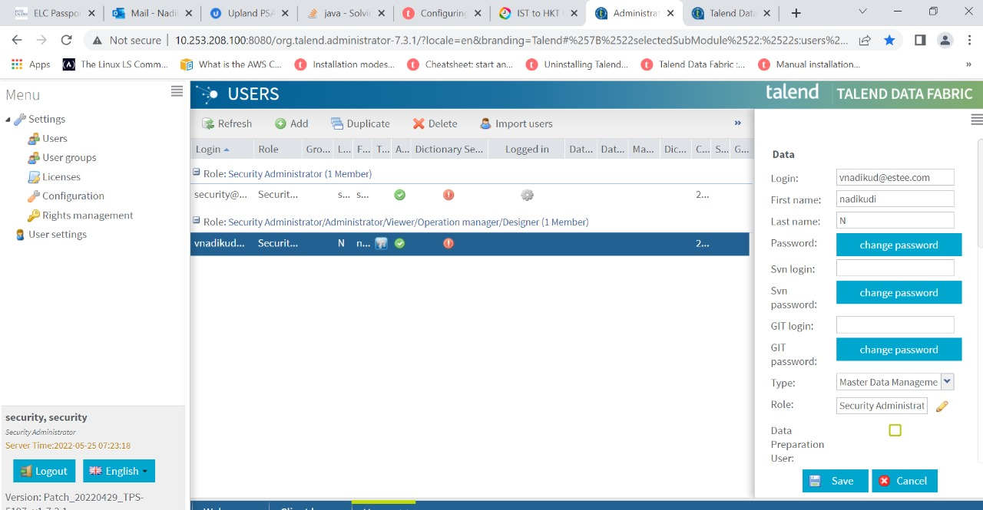

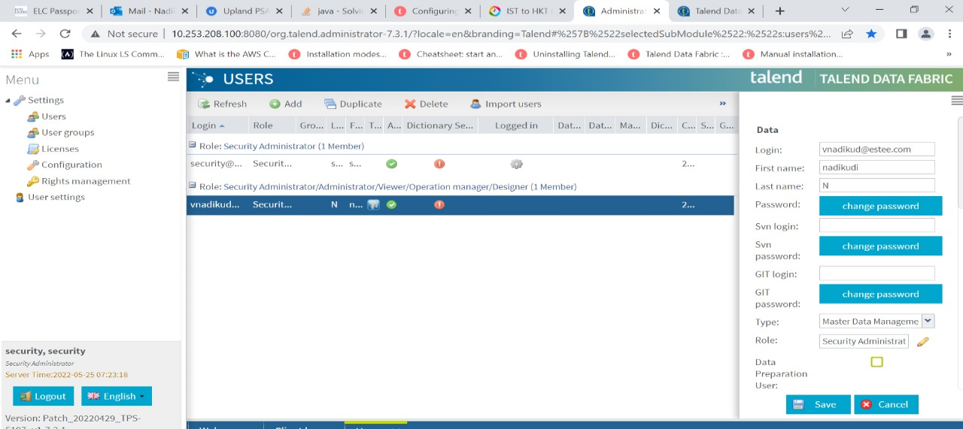

**Configuration UAT tac**

**Audit configuration:**

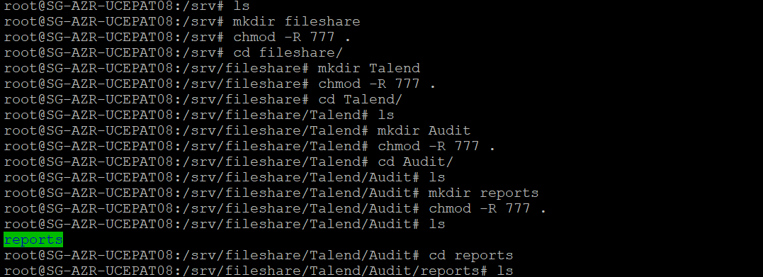

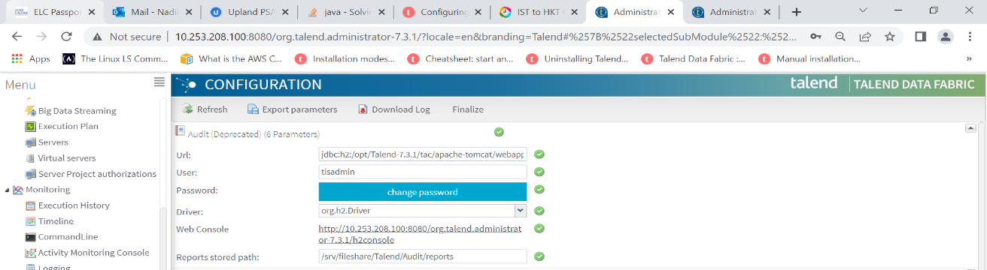

**Job conductor configuration:**

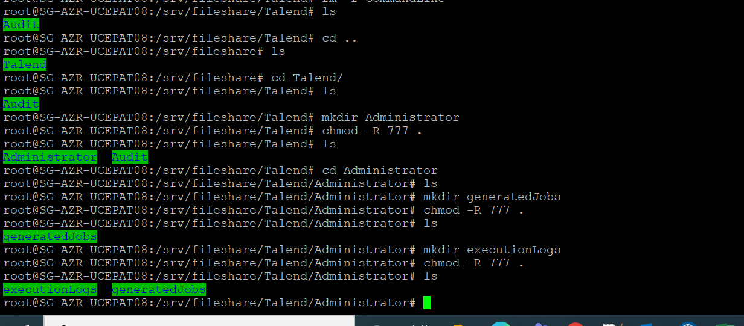

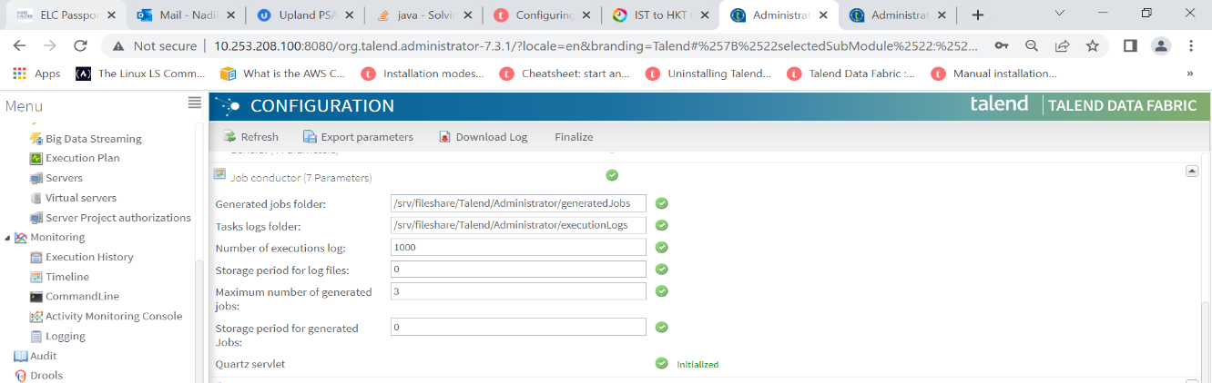

**Logs configuration:**

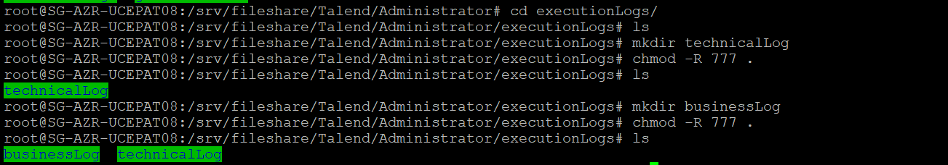

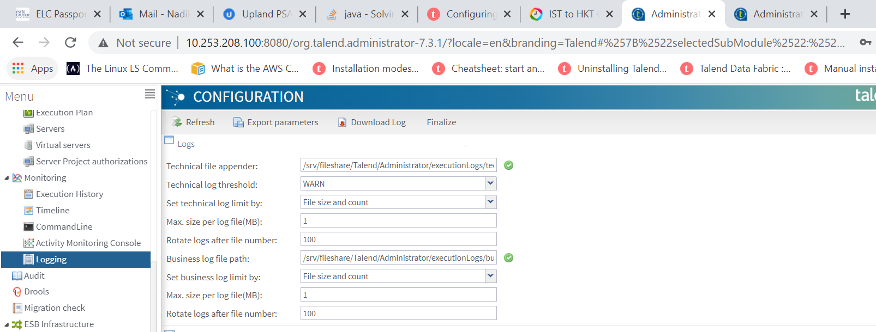

**Servers Configuration**

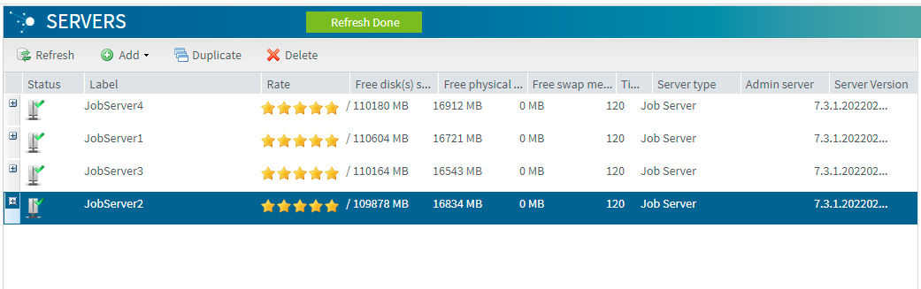

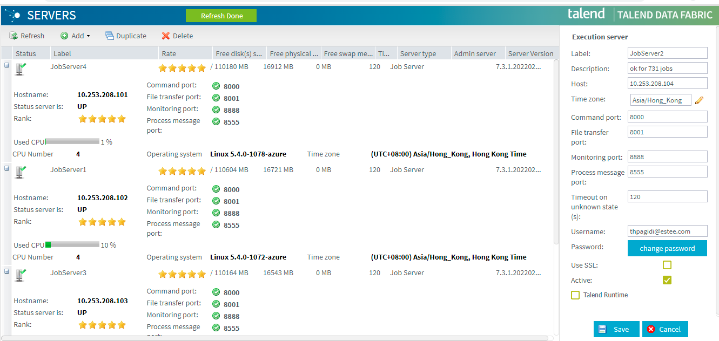

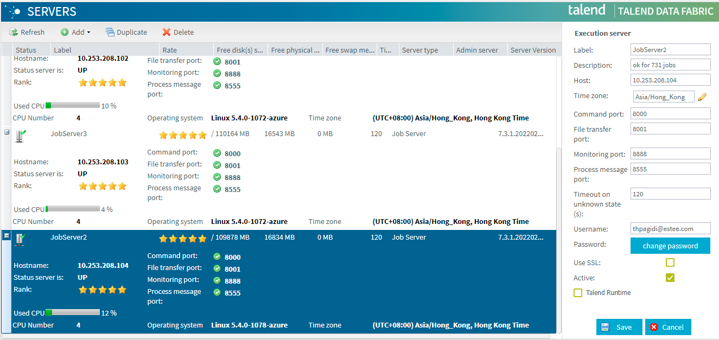

## TAC memory setting

**UAT (10.253.208.100)**

cd /opt/Talend-7.3.1/tac/apache-tomcat/bin

vi setenv.sh

Need to edit the press ‘i'

We are added min2g and max 12gb in this server 10.253.208.100

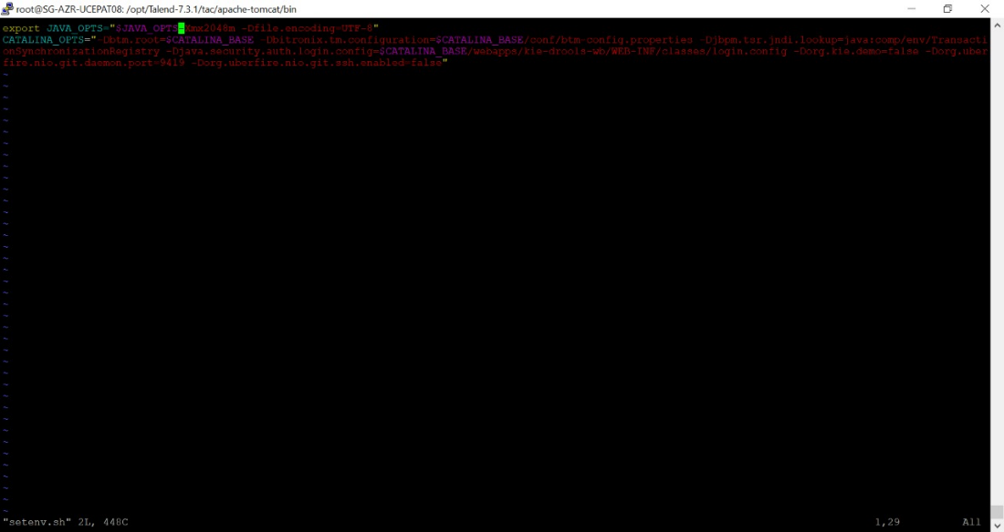

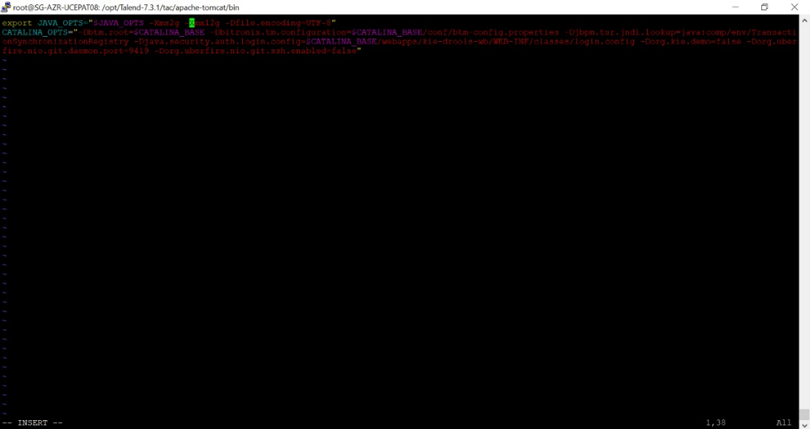

## Miscellaneous Configuration

1. **TAC config and quartz properties**

For both tac, follow below steps

cd /opt/Talend-7.1.1/tac/apache-tomcat/webapps/org.talend.administrator-7.1.1/WEB-INF/classes

edit configuration.properties

set hibernate.c3p0.max_size=320

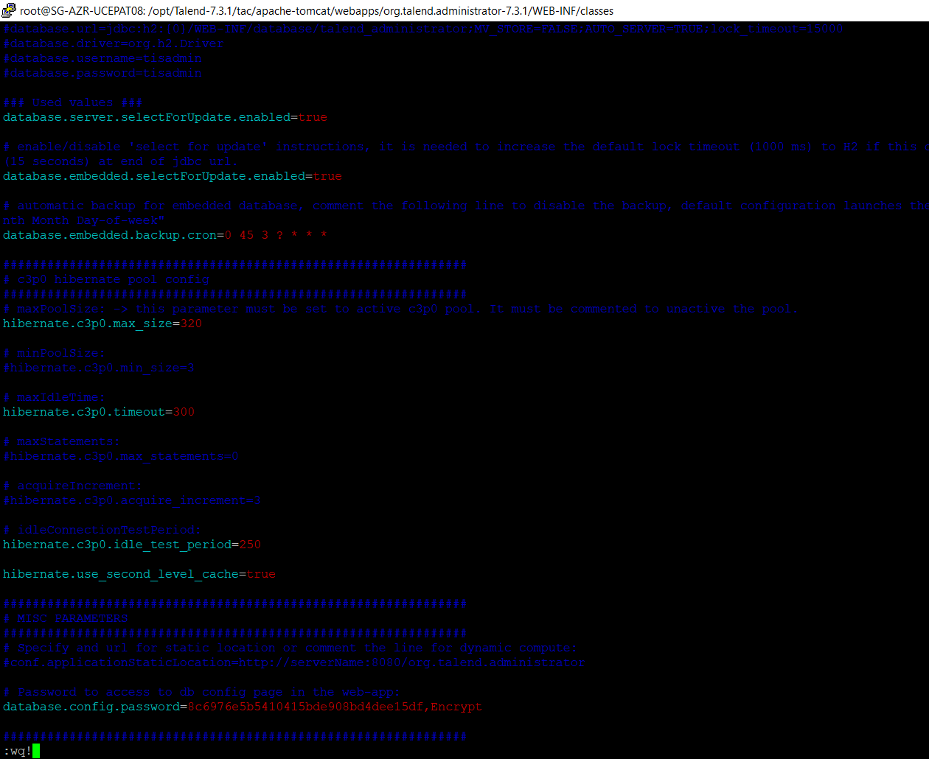

Edit quartz.properties

Set values for

org.quartz.threadPool.threadCount = 300

org.quartz.dataSource.QRTZ_DS.maxConnections = 300

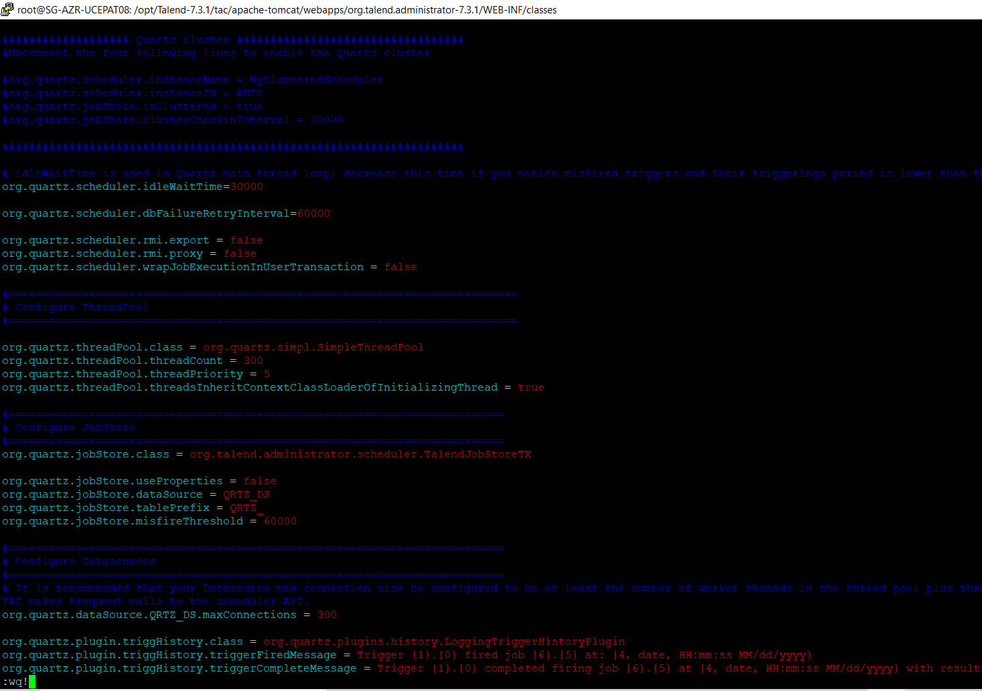

## TAC cache cleanup

Clean up temp, logs and work directory for tac

Then start tac service

## Create Logs Directories

Create paths in server and apply in Audit, Job Conductor and Logs section in TAC Configuration

Audit - /srv/fileshare/Talend/Audit/reports

Job Conductor - /srv/fileshare/Talend/Administrator/generatedJobs

Job Conductor - /srv/fileshare/Talend/Administrator/executionLogs

Logs - /srv/fileshare/Talend/Administrator/executionLogs/technicalLog/technical.log

Logs - /srv/fileshare/Talend/Administrator/executionLogs/businessLog/business.log

mkdir fileshare

cd fileshare

mkdir Talend

cd Talend

mkdir Audit Administrator

cd Audit

mkdir reports

cd ../Administrator

mkdir generatedJobs executionLogs

cd executionLogs

mkdir technicalLog businessLog

cd /srv

chmod -R 777 .

Audit _Configurtion:

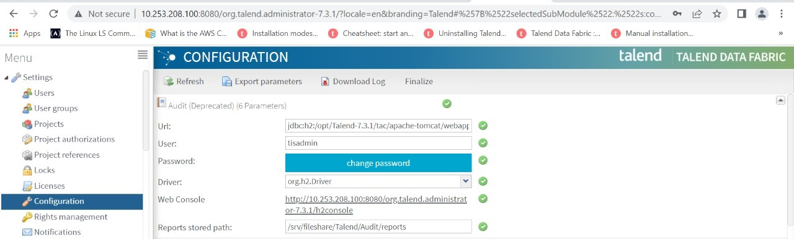

Jobconductor configuration:

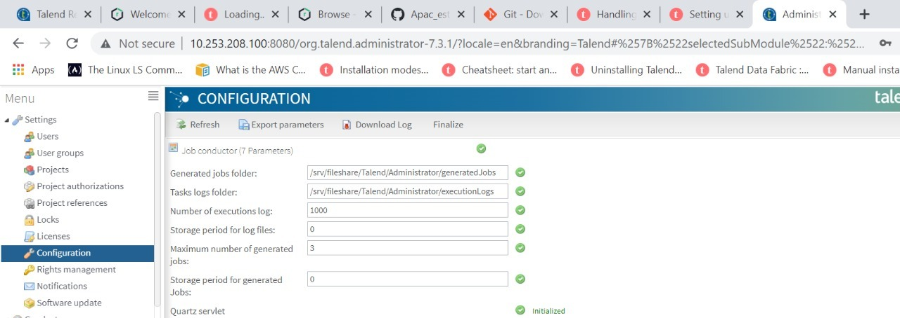

Logs_configuration:

Technical file appender - /srv/fileshare/Talend/Administrator/executionLogs/technicalLog/technical.log

Businesses log file path - /srv/fileshare/Talend/Administrator/executionLogs/businessLog/business.log

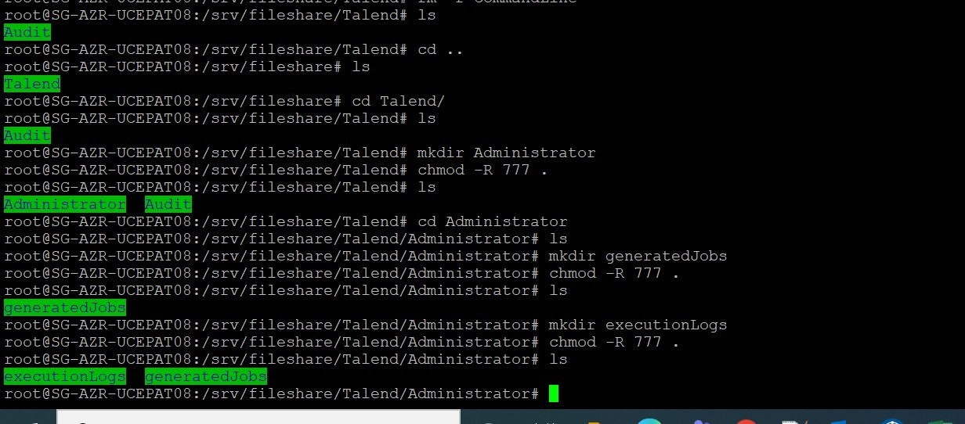

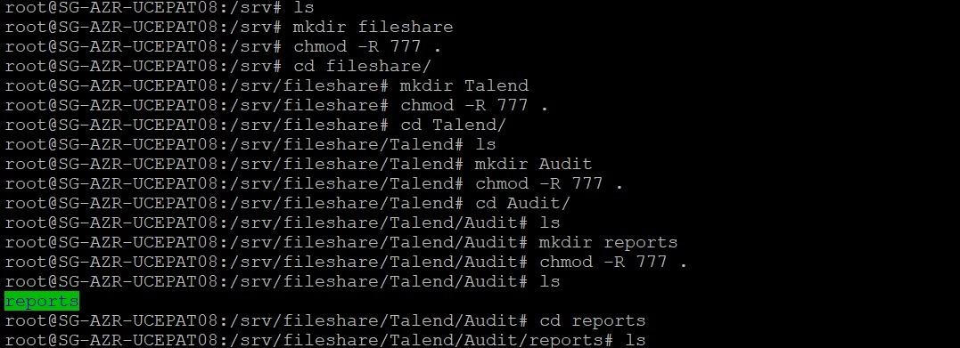

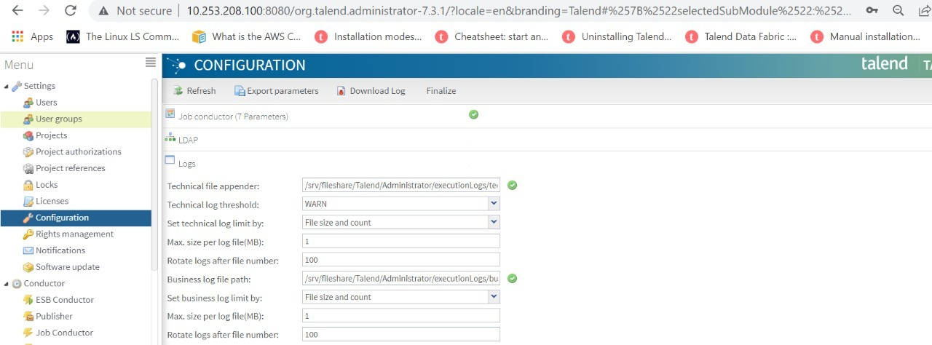

SMTP Config:

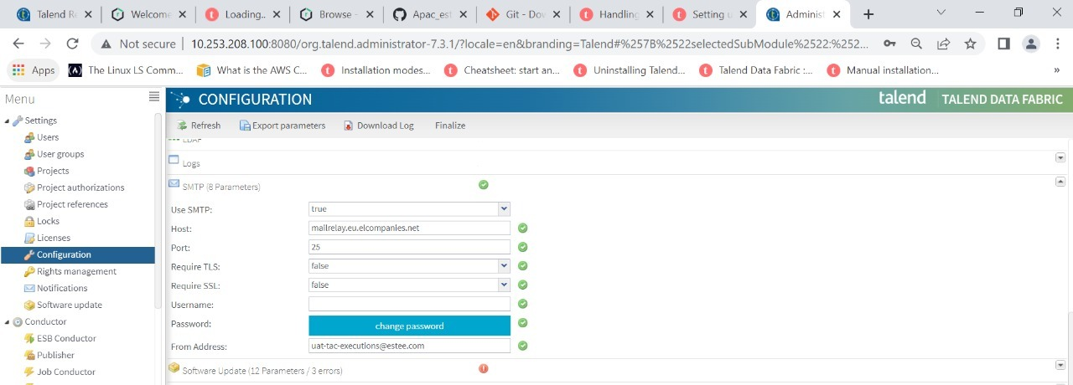

User Libraries

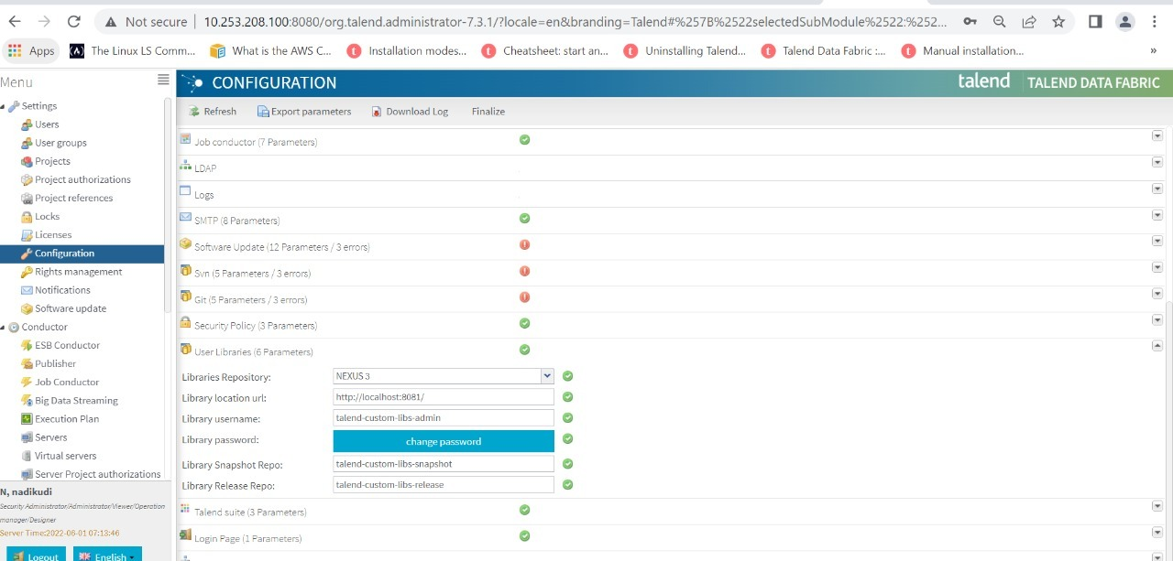

## Create GIT Project in TAC and create TAC users

# URL and Talend Service Names

## URL

UAT TAC - http://10.253.208.100:8080/org.talend.administrator-7.3.1

Nexus -

## Service Names

Service path - /etc/systemd/system

talend-tac-7.1.1

talend-rjs-7.1.1





# Apply SSL in TAC

EsteeKorea2020

|  |
| --- |
| Download Keystore Explorer |
| Download Root and Main Certificates |
| Examine certificate in Keytool Explorer |
| Select first certificate from top and click import |
| Keep selecting next certificates and click import |
| Select main certificate and import |
| Save as .p12 files |
|  |
| Open Keystore Explorer |
|  |
| Select import Keypair PKCS8 format -> OpenSSL -> apply main certificate path and decryption password (in this case, Winter123 same as server machine) |
| Click save as .jks file |
|  |
| cd /usr/lib/jvm/jdk1.8.0_211/bin |
| keytool -list -v -keystore /opt/Talend-7.1.1/keystore/estee_korea_dev.jks |

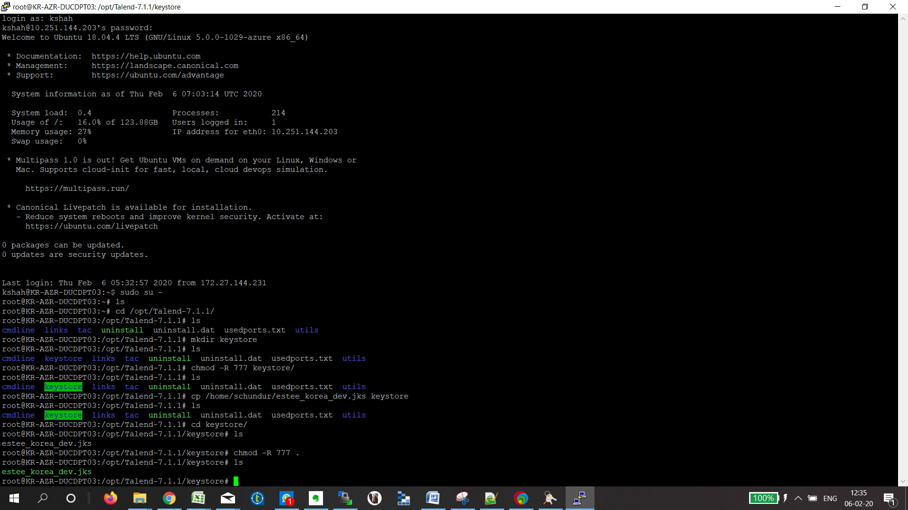

Edit server.xml as below

Disable http connected and enable https connector with settings applied

<Connector SSLEnabled="true" acceptCount="100" clientAuth="false"

connectionTimeout="20000" maxHttpHeaderSize="8192"

protocol="org.apache.coyote.http11.Http11NioProtocol" scheme="https" secure="true" sslProtocol="TLS"

disableUploadTimeout="true" enableLookups="false" maxThreads="25"

port="8080" redirectPort="8443" keystoreFile="/opt/Talend-7.1.1/keystore/estee_korea_dev.jks"

keystorePass="EsteeKorea2020" />

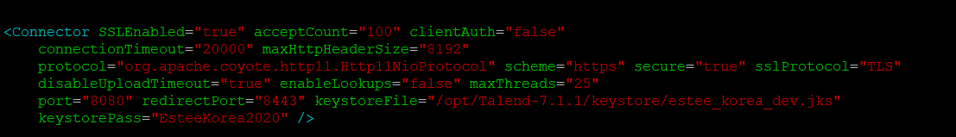

Clear TAC logs, temp and work directories under apache-tomcat

Restart tac service and Login with https url

<http://10.253.208.100:8080/org.talend.administrator-7.3.1/>

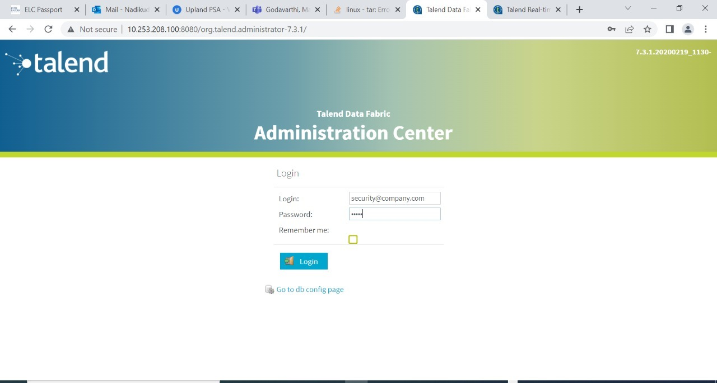

# TAC Patch Install

Download patch TPS-5197from url below

TPS-5197:

<https://talend-update.talend.com:443/nexus/service/local/repositories//Talend_Patches_For_Release_7.3.1/content/org/talend/tac/patch/full/Patch_20220429_TPS-5197_v1/7.3.1/Patch_20220429_TPS-5197_v1-7.3.1.zip>

Copy the patch zip file to /home/<user>directory on TAC server

1. Install Patch as instructed in Patch Readme file and refer to high level steps below

i. shut down tac

ii. take back up of org.talend.administrator-7.3.1 and remove this directory and remove .war from webapps

iii. apply patch .war file to webapps directory (do not apply config and quartz files yet)

iv. restart tac so .war creates org.talend.administrator-7.3.1 directory

v. Shut down TAC

vi. Now apply config and quartz files from backup

vii. clear tac cache (temp, logs, work)

viii. restart tac

Create backup ::cp -r org.talend.administrator-7.3.1/ org.talend.administrator-7.3.1_backup

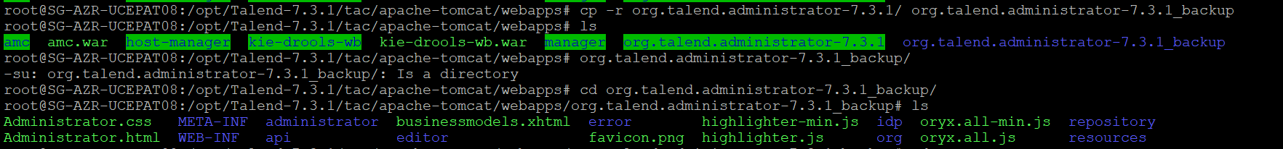

Move the backup directory from one path to another path



Remove the org.talend.administrator-7.3.1 and .war files from the server and apply patches

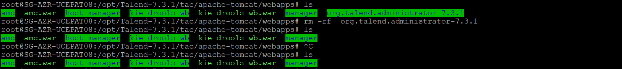

apply patch .war file to webapps directory

After restart tac so .war creates org.talend.administrator-7.3.1 directory

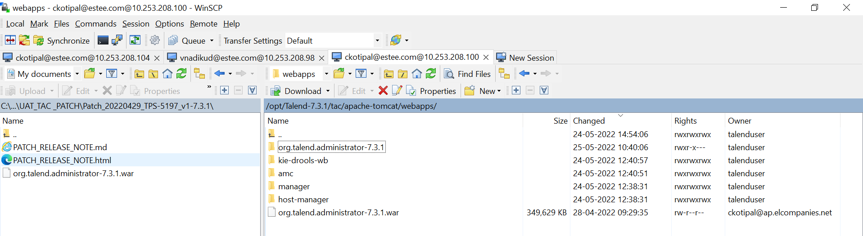

1. Then execute steps below

cd /opt/Talend-7.3.1

chown -R root:root tac

chmod -R 777 tac

ls -lrt

1. Edit user and group in Service and Start Service

cd /etc/systemd/system

vi talend-tac-7.3.1.service

apply user=root and group =root

:wq!

service talend-tac-7.3.1 status

systemctl daemon-reload

cd /opt/Talend-7.3.1/tac/apache-tomcat/logs

rm -rf

cd ../work

rm -rf

cd ../temp

rm -rf

service talend-tac-7.3.1 start

service talend-tac-7.3.1 status

cd /opt/Talend-7.3.1/tac/apache-tomcat/logs

tail -300 catalina.out

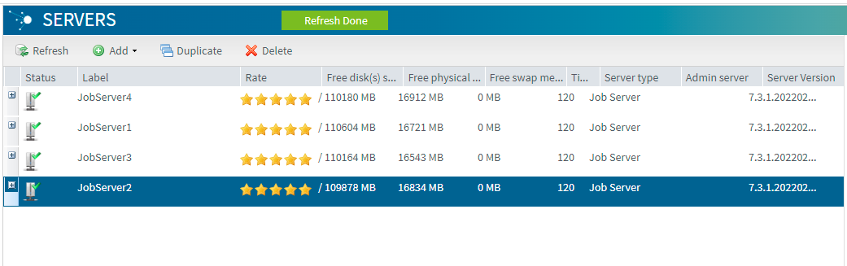

1. Change User and Group in Nexus service

cd /etc/systemd/system

vi talend-nexus-7.3.1. service

apply user=root and group =root

service talend-nexus-7.3.1 status

systemctl daemon-reload

service talend-nexus-7.3.1 start

# Prepare project Talend_ELCConsumerMDM in Studio

## Import Jobs from 711 project and check for compilation errors

## Create DB schema/tables/views and stored procedures in DEV mysql

1. Export all DB structures from APAC or CHINA DEV for mdmlanding and import into mdmlanding for Korea DEV

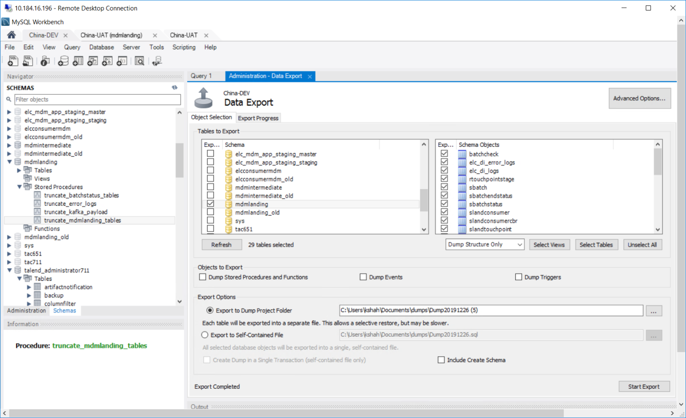

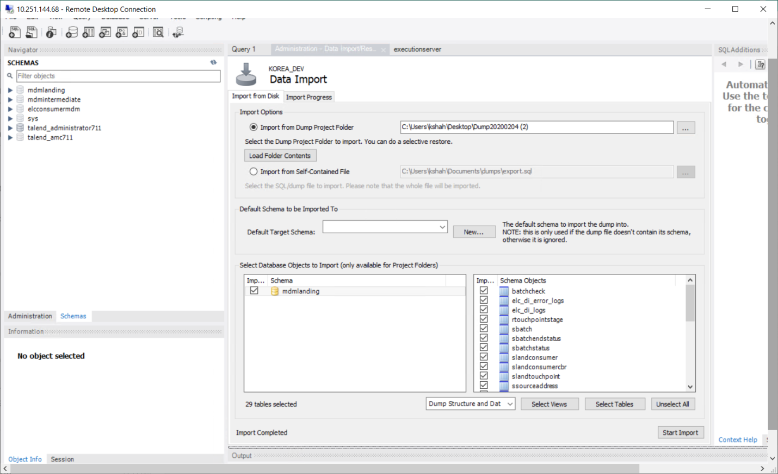

1. Export all DB structures from APAC or CHINA DEV for mdmintermediate and import into mdmintermediate for Korea DEV

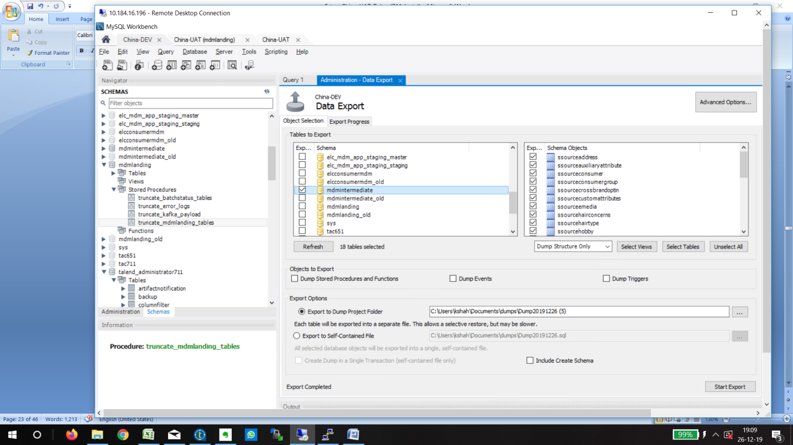

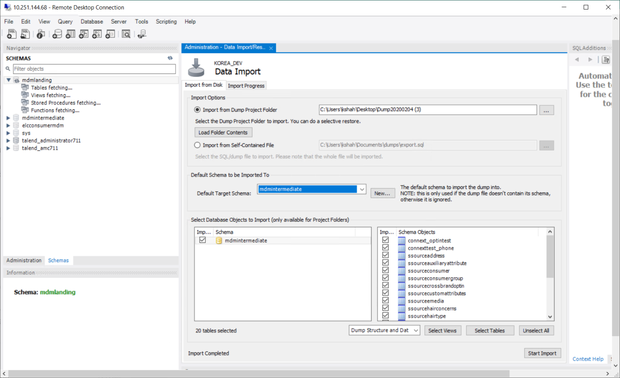

1. Export all DB structures from APAC or CHINA DEV for elcconsumermdm and import into elcconsumermdm for Korea DEV

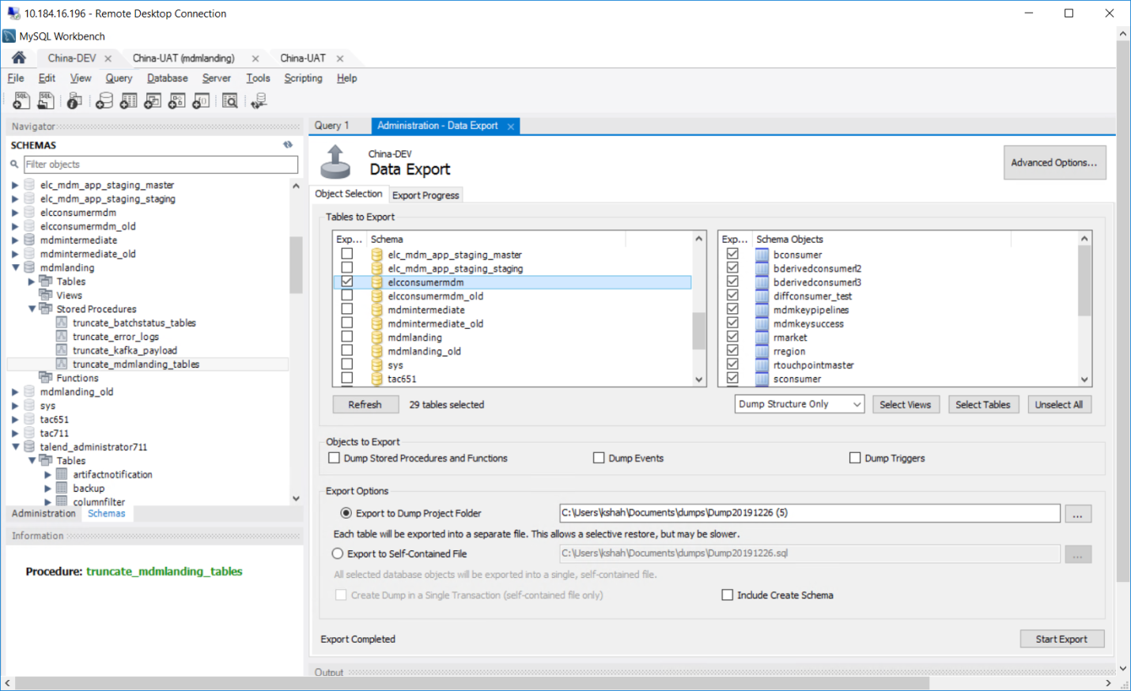

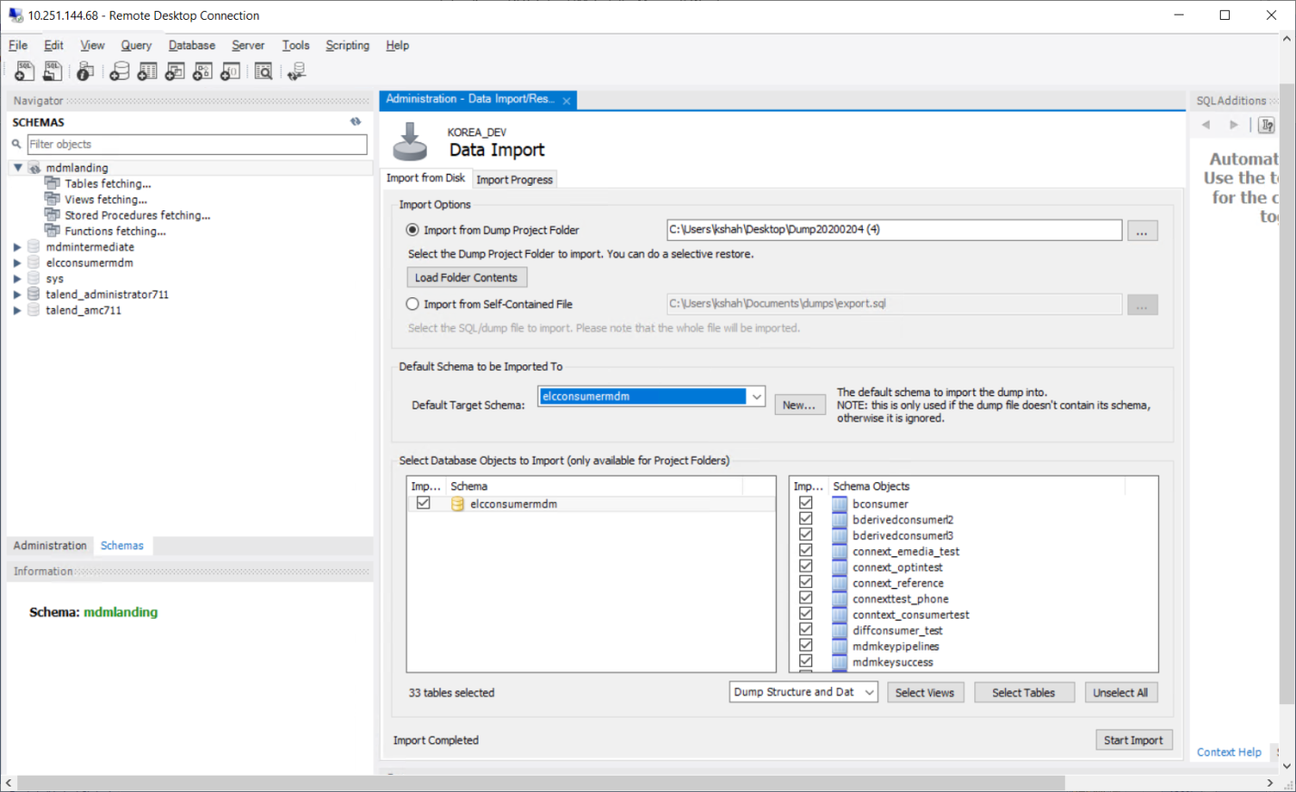

1. Copy all 4 stored procedures one by one APAC DEV mdmlanding db and execute onto Korea DEV mdmlanding db

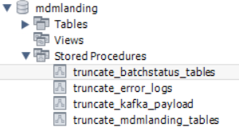

Make sure to change user to cdpadmin while creating stored procedures in KOREA DEV, since user is sqladmin for DEV and mysql user credentials are case sensitive

In APAC DEV:

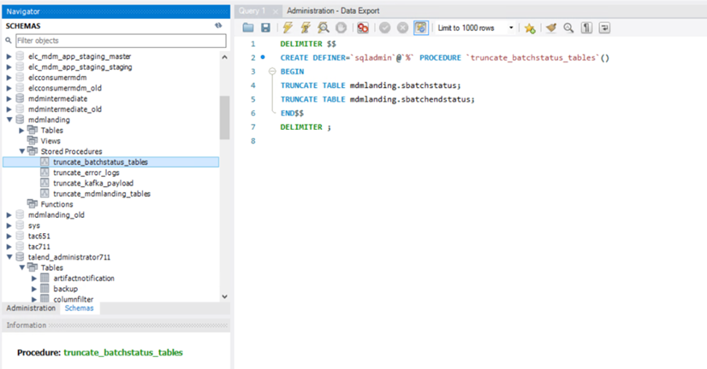

In KOREA DEV:

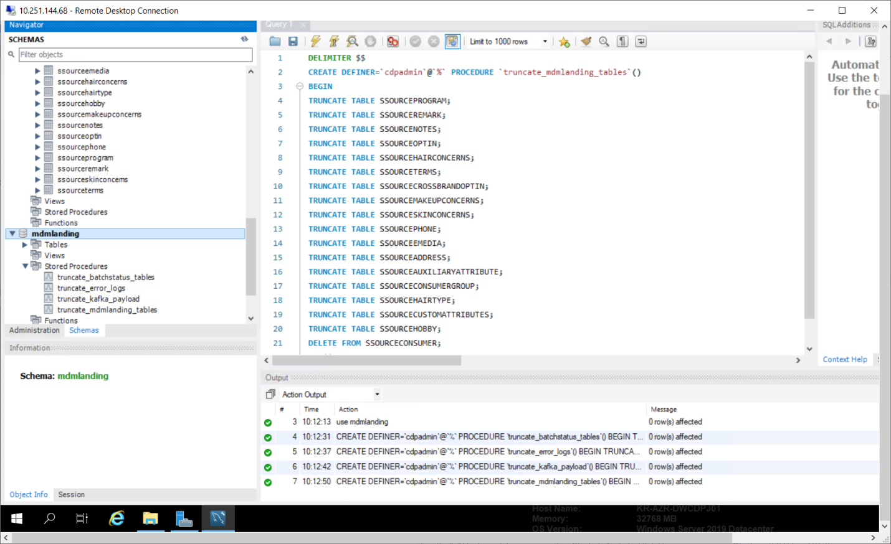

Create all stored procedures similarly in mdmlanding db.

1. Copy the stored procedure APAC DEV mdmintermediate db and execute onto Korea DEV mdmintermediate db

Again, make sure to change user to cdpadmin while creating stored procedures in Korea DEV

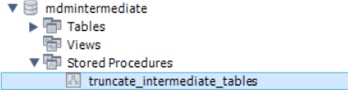

1. Copy the stored procedure APAC DEV elcconsumermdm db and execute onto Korea DEV elcconsumermdm db

Again, make sure to change user to cdpadmin while creating stored procedures in Korea DEV

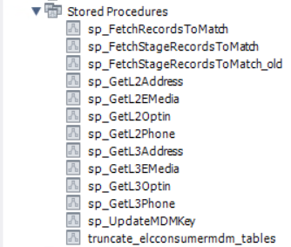

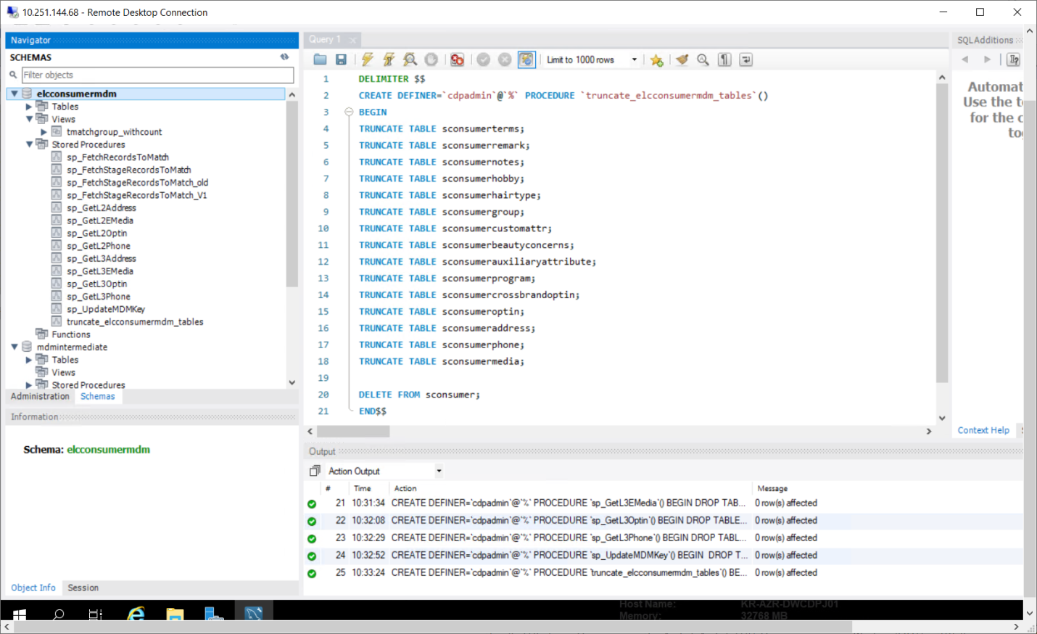

1. Copy the script to create views from APAC DEV elcconsumermdm db and execute onto Korea DEV elcconsumermdm db

Again, make sure to change user to cdpadmin while creating views in Korea DEV

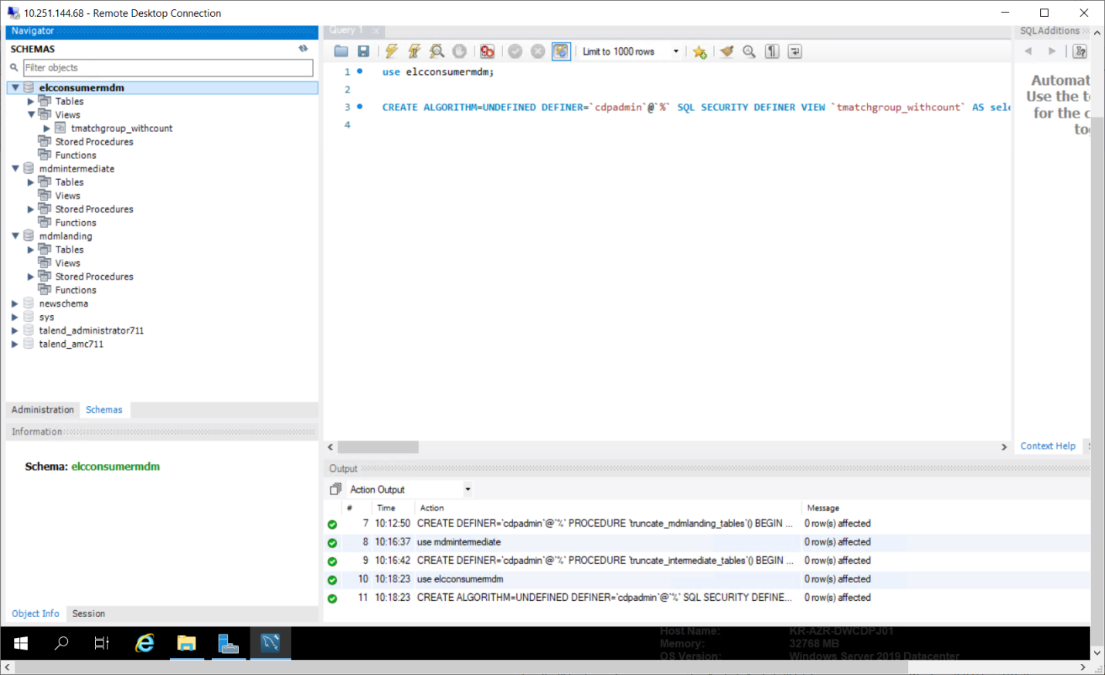

There are no views for mdmlanding db and mdmintermediate db.

8. Export Talend Metadata DB and update region to Korea in table

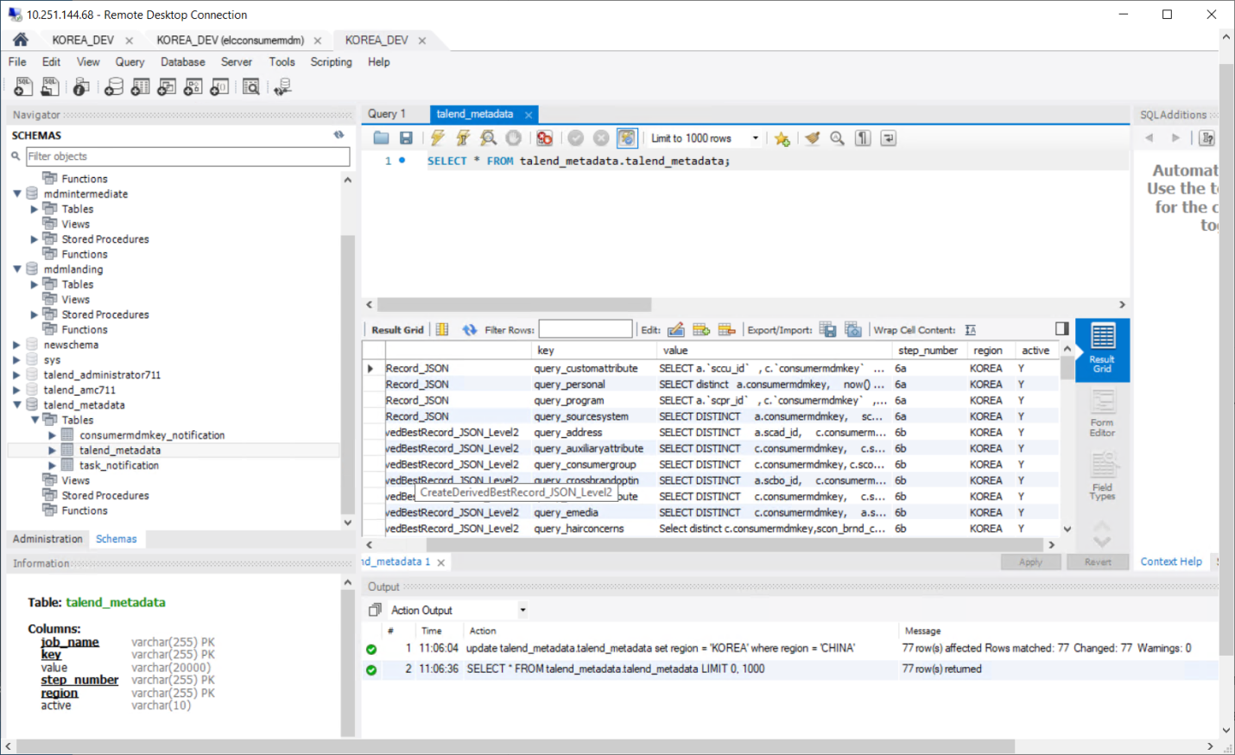

## Update DEV Context Group for mysql DB and kafka

1. Import APAC jobs in KOREA Project

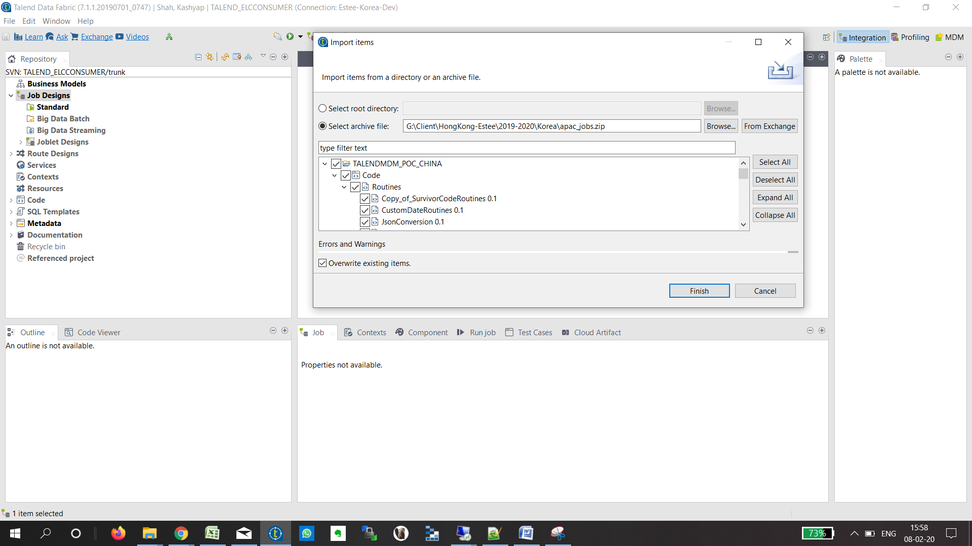

1. Edit context ELC_DB_Connection and update dev parameters with KOREA mysql values

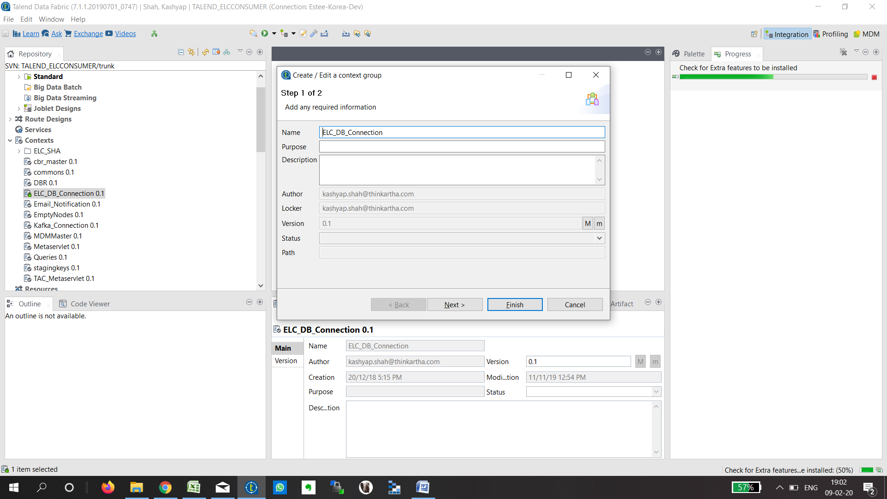

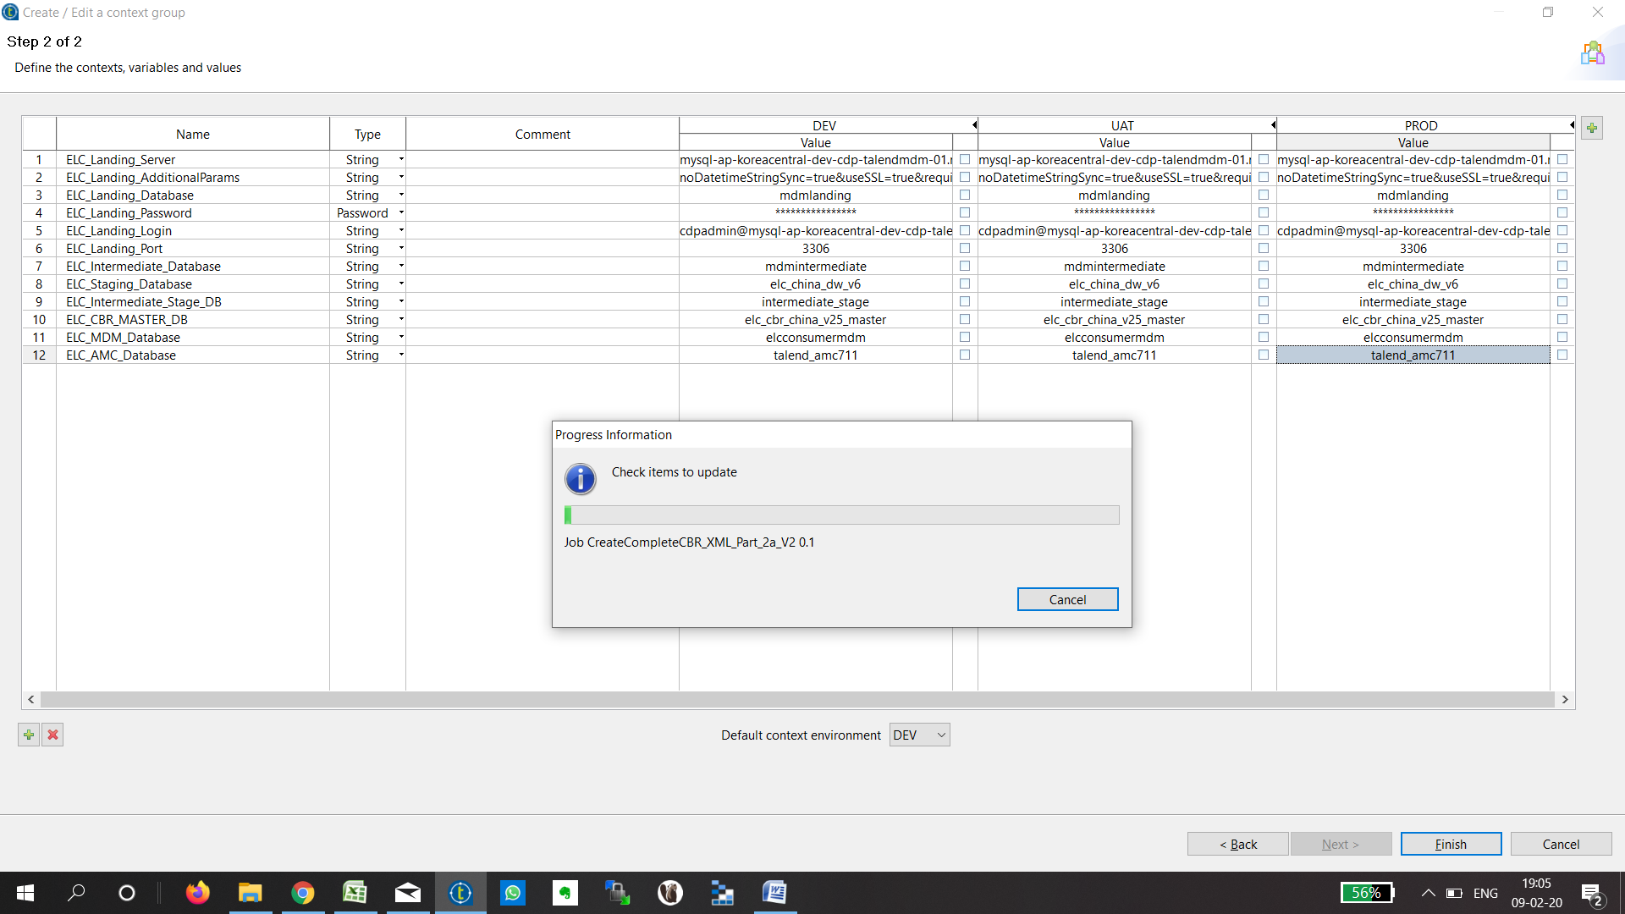

## Verify DB values updated and check for compilation errors in each job

Step 1 – LandKafkaMessage

LandKafkaMessageReset

Step 2

MJ_Consumer_Data_Parsing_BV4

SJ_ConsumerContactDataLoad_BV4

SJ_ConsumerOtherDataLoad_BV4

SJ_ConsumerOtherPersonalDataLoad_BV4

SJ_ConsumerPersonalDataLoad_BV4

SJ_ConsumerProgramDataLoad_BV4

Step 3

Landing_to_Intermediate_Standardization_V3

Step 4

Consumer_Matching_TSwoosh_F02_Under_Review

Consumer_Matching_TSwoosh_with_tsystem

Step 5

AssignPipelIneToMDMKey_4pipes

Intermediate_to_Stage_1_NPL01

Intermediate_to_Stage_2_NPL01

Step 6

CreateBestRecord_JSON

CreateDerivedBestRecord_JSON_Level2

CreateDerivedBestRecord_JSON_Level3_V4

Truncate_CBR_TempTable

Truncate_DBR_L2_TempTable

Truncate_DBR_L3_TempTable

Step 7

CreateFinalCBRL_JSON_And_PushToKafka_WithKey_V7

Step 8

Update_Flag_V2

## Publish to Nexus or Build each job from studio, upload job zip to TAC task, configure contexts, test execute and view logs

Touchpoint Jobs

**Step 1**

HKG_ UAT_1_LandKafkaMessage_V7

LandKafkaMessage_ResetOffset

**Step 2**

HKG_ UAT_2a_Consumer_Data_Parsing_Personal_BV9

HKG_ UAT_2b_Consumer_Data_Parsing_Contact_BV5_1

HKG_ UAT_2c_Consumer_Data_Parsing_Other

HKG_ UAT _2d_Consumer_Data_Parsing_OtherPersonal

HKG_ UAT _2e_Consumer_Data_Parsing_Program

**Step 3**

HKG_ UAT _3_Landing_to_Intermediate_Standardization

**Step 4**

HKG_ UAT _4_Consumer_Matching_TSwoosh

HKG_ UAT _4_Consumer_Matching_TSwoosh_with_tsystem

**Step 5**

HKG_ UAT _5_1_Intermediate_to_Stage_1

HKG_ UAT _5_2_Intermediate_to_Stage_2

HKG_ UAT _5_3_AssignPipelIneToMDMKey_4pipes

**Step 6**

HKG_ UAT _6aa_TruncateCBR

HKG_ UAT _6b_TruncateDBR_Level2

HKG_ UAT _6cc_TruncateDBR_Level3

HKG_ UAT _6a_CreateCBR_JSON_V8_2_S1

DEV_6a_CreateCBR_JSON_S2

DEV_6a_CreateCBR_JSON_S3

DEV_6a_CreateCBR_JSON_S4

HKG_ UAT _6b_CreateDBR_L2_V10_2_S1

HKG_ UAT _6b_CreateDBR_L2_V10_2_S2

HKG_ UAT _6b_CreateDBR_L2_V10_2_S3

HKG_ UAT _6b_CreateDBR_L2_V10_2_S4

HKG_ UAT _6c_CreateDBR_L3_V10_2_S1

HKG_ UAT _6c_CreateDBR_L3_V10_2_S2

HKG_ UAT _6c_CreateDBR_L3_V10_2_S3

HKG_ UAT _6c_CreateDBR_L3_V10_2_S4

**Step 7**

HKG_ UAT _7a_CreateFinalCBRL_JSON_And_PushToKafka_V14_S1

HKG_ UAT _7a_CreateFinalCBRL_JSON_And_PushToKafka_V14_S2

HKG_ UAT _7a_CreateFinalCBRL_JSON_And_PushToKafka_V7_S3

HKG_ UAT _7a_CreateFinalCBRL_JSON_And_PushToKafka_V7_S4

**Step 8**

HKG_UAT _8_Update_Flag_and_Send_Email_Rest_All_Markets_V2_1

## Create Execution Plan and execute once

**ELC_Consumer_MDM_HKG_V2**

## Execute same batch of data using 711 Execution Plan and 731 execution Plan and verify in Kafka Topic – HKG Plan selected

**8.6.1. 731 Execution of Batch ID \*\*\***

**Logs:**

**HKG_UAT_1_LandKafkaMessage_V7**

**HKG_UAT_2a_Consumer_Data_Parsing_Personal_BV9**

**HKG_ UAT _2b_Consumer_Data_Parsing_Contact_BV5_1**

**HKG_ UAT _2c_Consumer_Data_Parsing_Other_BV5_1**

**HKG_ UAT _2d_Consumer_Data_Parsing_OtherPersonal_BV5_1**

**HKG_ UAT _2e_Consumer_Data_Parsing_Program_BV5_1**

**HKG_ UAT _3_Landing_to_Intermediate_Standardization_V9_2**

**HKG_ UAT _4_Consumer_Matching_TSwoosh**

**HKG_ UAT _5_1_Intermediate_to_Stage_V9**

**HKG_ UAT _5_2_Intermediate_to_Stage_V9_2**

**HKG_ UAT _5_3_AssignPipelIneToMDMKey_4pipes**

**HKG_ UAT _6aa_TruncateCBR**

**HKG_ UAT _6a_CreateCBR_JSON_V8_2_S1**

**HKG_ UAT _6a_CreateCBR_JSON_V8_2_S2**

**HKG_ UAT _6a_CreateCBR_JSON_V8_2_S3**

**HKG_ UAT _6a_CreateCBR_JSON_V8_2_S4**

**HKG_ UAT _6bb_TruncateDBR_Level2**

**HKG_ UAT _6b_CreateDBR_L2_V10_2_S1**

**HKG_ UAT _6b_CreateDBR_L2_V10_2_S2**

**HKG_ UAT _6b_CreateDBR_L2_V10_2_S3**

**HKG_ UAT _6b_CreateDBR_L2_V10_2_S4**

**HKG_ UAT _6cc_TruncateDBR_Level3**

**HKG_ UAT _6c_CreateDBR_L3_V10_2_S1**

**HKG_ UAT _6c_CreateDBR_L3_V10_2_S2**

**HKG_ UAT _6c_CreateDBR_L3_V10_2_S3**

**HKG_ UAT _6c_CreateDBR_L3_V10_2_S4**

**HKG_ UAT _7aa_Placeholder**

**HKG_ UAT _7a_CreateFinalCBRL_JSON_And_PushToKafka_V14_S1**

**HKG_ UAT _7a_CreateFinalCBRL_JSON_And_PushToKafka_V14_S2**

**HKG_ UAT _7a_CreateFinalCBRL_JSON_And_PushToKafka_V14_S3**

**HKG_ UAT _7a_CreateFinalCBRL_JSON_And_PushToKafka_V14_S4**

**HKG_ UAT _8_Update_Flag_and_Send_Email_Rest_All_Markets_V2_1**

**8.6.2. Execution of Batch ID \*\*\***

Below are the Json files for 5 MDMKeys of Batch ID *** in Talend 731 from APAC DEV Kafka Topic CBR_HK

Verified below 5 mdmkeys and confirmed outbound json are identical processed from Talend 731 and Talend 711.